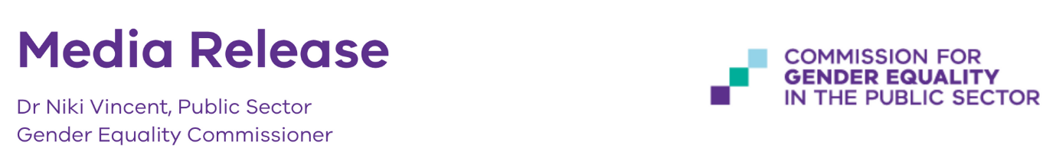5 September, 2022

**VICTORIA LEADS THE WAY WITH GENDER EQUALITY AUDIT**

Around 300 of Victoria’s public sector organisations employing more than 450,000 workers in total have participated in Australia’s first mandatory workplace gender equality audit.

Under the landmark Gender Equality Act, all state government departments and authorities, emergency services, councils and universities must measure workplace gender inequality to make improvements.

The audit found that the average pay gap between men and women was 15.6%. This means that, on average, men took home $19,000 more than women across the 2020-21 financial year.

Women’s participation in the paid Victorian workforce increased substantially over the past 5 decades, rising from 43.8% in 1978 to 62.3% in June 2022. In public sector organisations 66% of employees are women, but only 45% of those in senior leadership roles were women and more than 3 in 5 chief executives were men.

In comparison, in the private sector, Australia’s national gender pay gap was 22.8% or $25,792 as calculated by the Workplace Gender Equality Agency.

These findings are captured in our Baseline report, which also found:

* Women were significantly overrepresented in part-time and casual work, with 42% of women working part time, compared to 15% of men.
* More than three-quarters of workers using formal flexible work arrangements were women.
* Almost 8 out of 10 parental leave takers were women, and their leave lasted an average of 8 times longer than men’s.
* Women were 50% more likely to say they experienced sexual harassment than men but they rarely made a formal complaint about this. Sexual harassment occurred most frequently in majority-men and frontline sectors, such as transport and police and emergency services.
* The gender composition of governing bodies across defined entities overall was largely balanced between women and men. Victorian Government targets in place since 2015 requiring 50% of new government board appointments to be women have been successful in generating greater gender balance in public boards in Victoria.

Victoria now has the most comprehensive dataset on public sector workplace gender equality in Australia. In line with the new *Gender Equality Act 2020*, which came into effect last year, organisations have used the information to develop Gender Equality Action Plans and must publicly report their progress every two years. The Act requires that material progress is made.

This process uncovers gender inequality in the workplace and ensures employers are held publicly accountable for making progress towards equality.

This data is now available.

Visit the Insights Portal for individual organisation results at: <https://insights.genderequalitycommission.vic.gov.au/>

Access the Baseline report on sector-wide trends at: <https://www.genderequalitycommission.vic.gov.au/baseline-audit-report-2021>

**Quotes attributable to Public Sector Gender Equality Commissioner Dr Niki Vincent**

*“You can’t manage what you don’t measure – and we now have more transparency than ever before to understand the state and nature of gender inequality impacting a large component of Victoria’s workforce.”*

*“The baseline report shows Victoria’s public sector organisations are performing well in comparison to the private sector in some areas – and while there is still much progress to be made, there is a real appetite for change.”*

*“I am confident that Victoria will continue to lead by example in addressing the systemic drivers of gender inequality within the workforce.”*

For more information, visit [www.genderequalitycommission.vic.gov.au/](http://www.genderequalitycommission.vic.gov.au/research-grants)