|  |
| --- |
| Gender Equality Act Reporting Platform – User Guide |
| Standard User |



Contents

1 What is the Gender Equality Act Reporting Platform? 2

2 Accessing the reporting platform 4

3 Submitting my organisation’s workplace gender audit results 6

4 Submitting my organisation’s Gender Equality Action Plan 14

5 Submitting my organisation’s progress report 18

6 What happens after I submit my obligation? 21

7 Viewing my organisation’s data and reports 24

8 I need help with the reporting platform 30

9 Appendices 35

10 Version History 47

# What is the Gender Equality Act Reporting Platform?

The Gender Equality Act Reporting Platform supports defined entities in fulfilling their obligations under the Gender Equality Act 2020 by providing the following capabilities:

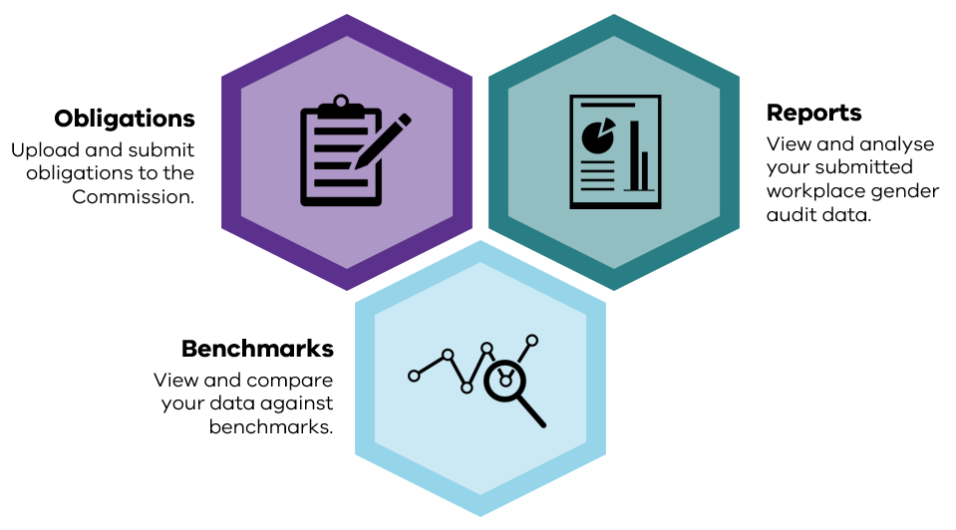

## Users

Each organisation can register users with the following roles and access to the reporting platform:

|  |  |
| --- | --- |
| **User role** | **Permissions of a user with this role** |
| Standard user | * Submit obligations * View organisation data |
| Read-Only user | * View organisation data |

## Obligations

Obligations under the Gender Equality Act 2020 that can be submitted via the reporting platform are:

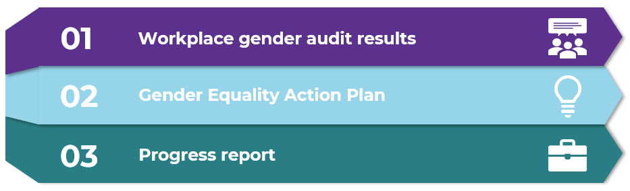

All obligations follow a common submission process on the reporting platform:



What does each status mean?

|  |  |
| --- | --- |
| **Obligation status** | **Description of status** |
| Not started | Obligation is available in the reporting platform for the organisation to begin submission. |
| Drafting | Obligation has been started and saved. |
| Review | For the audit obligation only, the obligation can be processed by platform reports to inspect data quality, public preview and indicator reports prior to submitting. From this state, the obligation can be edited again if further changes are needed. |
| Submitted | Obligation has been sent for review to the Commission. |
| Checking for compliance | The Commission is currently reviewing the obligation to ensure it meets all its requirements under the Gender Equality Act. |
| Re-submission required | The Commission has finalised their review and requires additional information or clarification in relation to the obligation. |
| Final | The Commission has finalised their review and there is no further action required in the reporting platform in regard to the obligation submission. In this status the obligation can be published to the Insights Portal website. |
| Re-submission requested | The defined entity has requested that they re-submit their obligation. Following approval by the Commission, the obligation will move into a state of re-submission required. |

# Accessing the reporting platform

**IMPORTANT:** Before attempting to log in to the reporting platform, ensure you have requested access to the reporting platform. Refer to Appendix A – Requesting access to the reporting platform

## How do I log in to the reporting platform?

Navigate to the following URL in your browser:

[**https://report.genderequalitycommission.vic.gov.au**](https://report.genderequalitycommission.vic.gov.au)

You may be prompted to sign in, if so, please select the account you used to request access to the reporting platform.

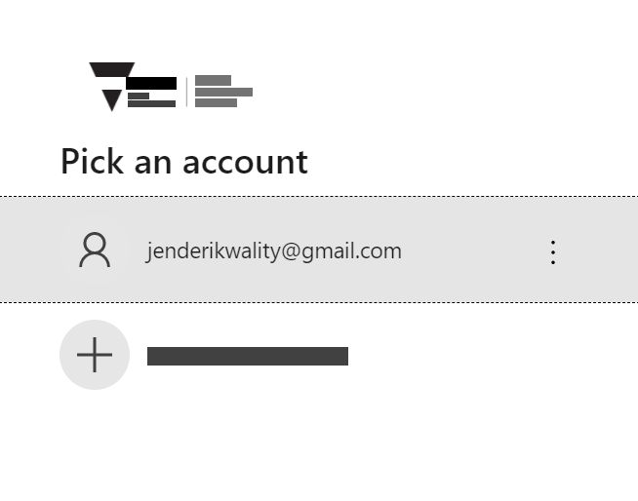

Enter password and click ‘Sign in’.

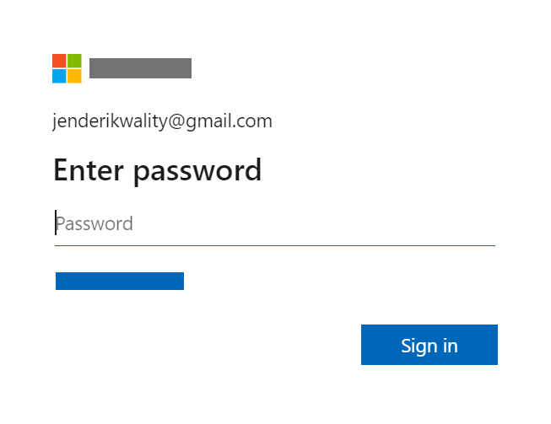

Upon successful sign in, you will see the ‘Obligations’ dashboard.

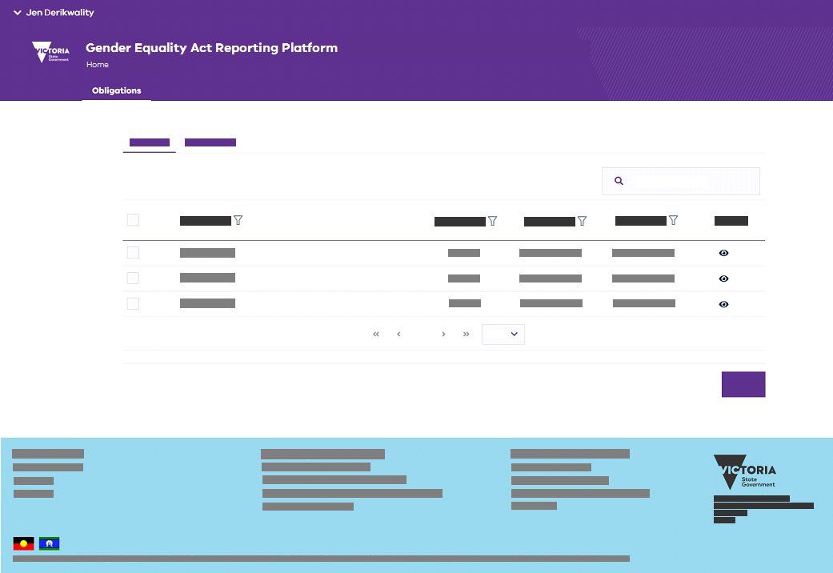

# Submitting my organisation’s workplace gender audit results

## How do I submit my audit results?

Submitting your audit results involves

1. Selecting and opening your ‘Workplace gender audit’ obligation
2. Adding workforce audit data to the obligation
3. Adding employee experience audit data to the obligation (if required)
4. Moving the audit to a status of ‘Review’ where it can be assessed for quality, the indicator reports inspected, and a preview of the public representation of the audit data displayed.
5. Moving the audit to a status of ‘Submitted’ where it can then be assessed by the Commission to ensure it meets all requirements under the Act, before being finalised.

To complete the process outlined above, proceed with the following steps.

### Open your audit record

1. On the Obligations dashboard page, locate the row for the workplace gender audit for the current reporting year.
2. Under the “Actions” column, click on the  icon.

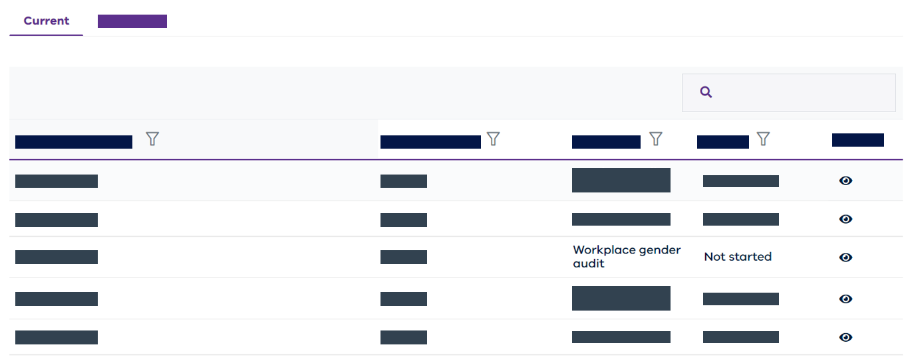

1. The workplace gender audit record will be opened for editing.

### Add workforce data

You can add workforce data in one of two forms

* As unit level records (recommended)
* In aggregate form

Uploading unit level records enables you to inspect a data quality report about your data. This can significantly increase the likelihood that your data will be correctly interpreted as part of your gender equality indicator data measures in reports (indicator and public).

1. To upload your unit level workforce data, go to the “Workforce Data” section, select “Unit Level (recommended)” and click “Choose an Excel file”.

|  |
| --- |
| For this step your will choose your workforce reporting template. Ensure you have used the most current version of the workforce reporting template found on the Commission’s website at [Progress audit 2023 | Commission for Gender Equality in the Public Sector](https://www.genderequalitycommission.vic.gov.au/progress-audit-2023)  **Important!** Before you choose and upload this template, ensure that you have completed all steps listed in the “Instructions” sheet of the template. |

1. In the file selection pop-up window, select the workforce reporting template and click “Open”.
2. Once file has loaded (i.e. the “Loading…” message is no longer displayed on screen), all five of the unit level data sets will be loaded and you will see the following view

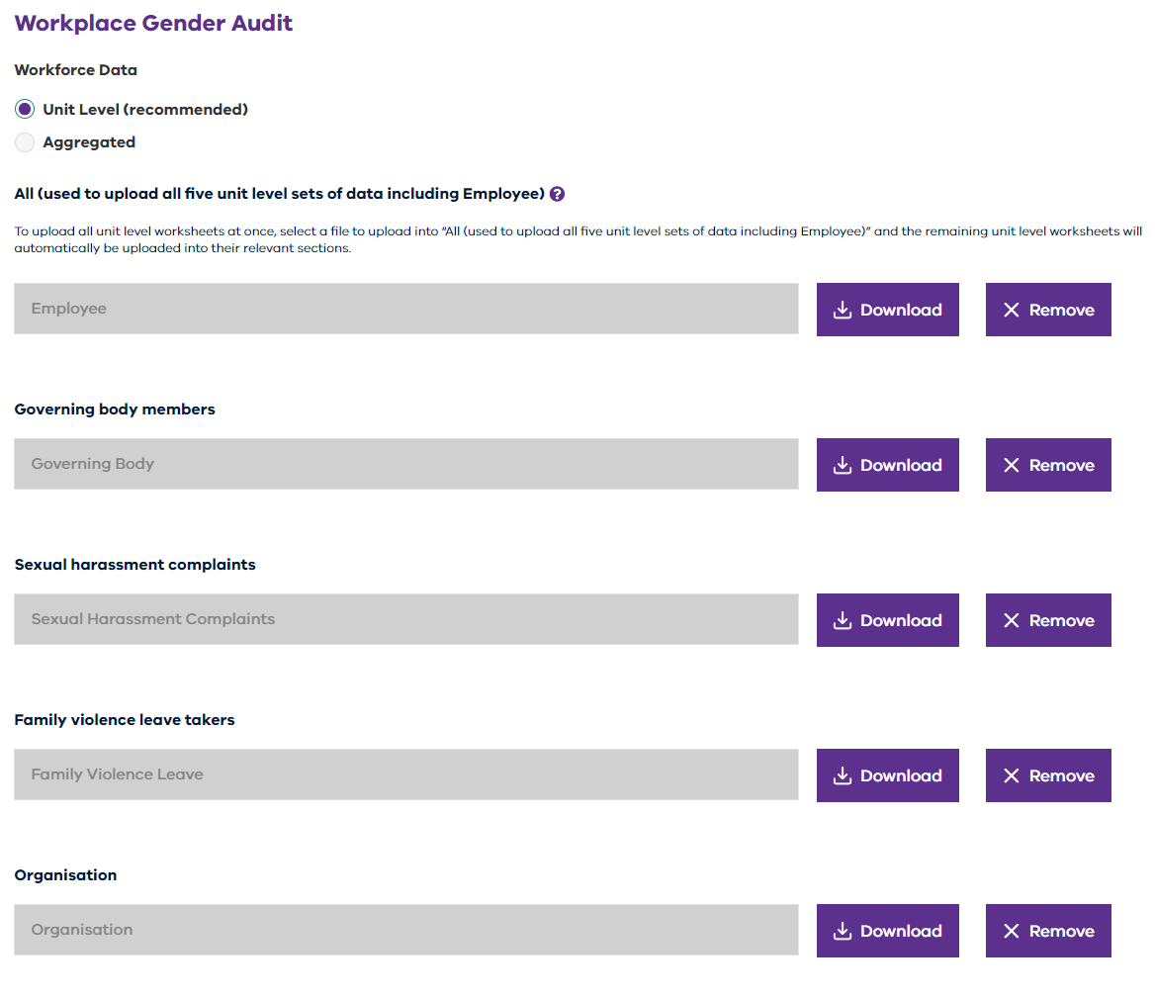

|  |
| --- |
| If you experience an error, refer to Appendix C – Error messages for guidance. |

1. Click “Save” to ensure that your changes have been made to your audit record.

**Adding aggregate data**

In place of unit level data, your organisation may wish to upload aggregate data. Before doing so, please consider the following

* Your data cannot be analysed by the self-service data quality report.
* Consequently, it may be less likely to meet the Commission’s requirements when submitted. Any feedback subsequently received from the Commission that requires you to modify your audit data may then have a flow-on impact to the results you have derived from that data and which you are using in your progress report or GEAP.
* You will need to first collect your unit level data before transforming it into an aggregated form. The transformation will require an additional template and process steps which the Commission will be happy to supply and guide you to complete.
* If you wish to submit aggregate data, please contact the Commission at [enquiries@genderequalitycommission.vic.gov.au](mailto:enquiries@genderequalitycommission.vic.gov.au) to request further information

1. To upload your aggregate workforce data, go to the “Workforce Data” section, select “Aggregated” and click “Choose an Excel file

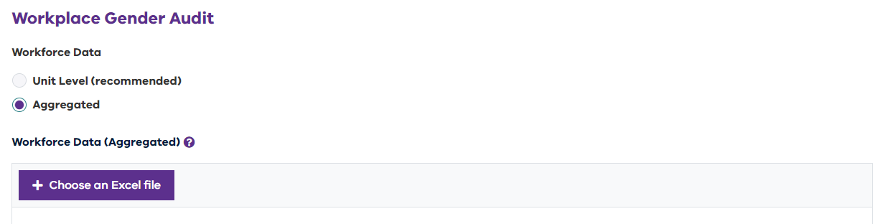

|  |
| --- |
| For this step your will choose an aggregated workforce reporting template that has been supplied by the Commission. This is a different template to the workforce reporting template found on the Commission’s website. If you attempt to submit your data using the Commission’s standard workforce reporting template, you will be presented with an error. |

1. In the file selection pop-up window, select the aggregated workforce reporting template and click “Open”.
2. Once file has loaded (i.e. the “Loading…” message is no longer displayed on screen), the aggregated data will be loaded and you will see the following view
3. Click “Save” to ensure that your changes have been made to your audit record.

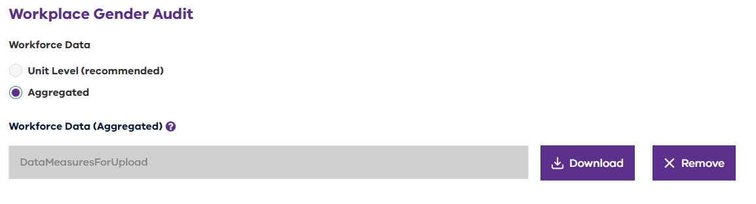

### Add employee experience data (if required)

|  |
| --- |
| Important! This step is only applicable to organisations that did not participate in the VPSC People Matter Survey.  If your organisation participated in the VPSC People Matter Survey, then the section of the audit record relating to Employee Experience Data (Aggregated) will be shown greyed out and you will not be able to modify it.  Before the VPSC PMS data is available, this section of your audit record will appear as follows    After the VPSC PMS data is available, the section of your audit record will appear as follows.    In both cases, you are not required to, and will not be able to edit this section of the audit record.  The Commission will attach your organisation’s employee experience data to your audit once it has been supplied by the VPSC. This will occur after the VPSC have released the PMS data to your organisation. |

1. To upload your aggregated employee experience data, go to “Workforce Data”, select “Aggregated”. Then click “Choose an Excel file” in the “Employee Experience Data (Aggregated)”.

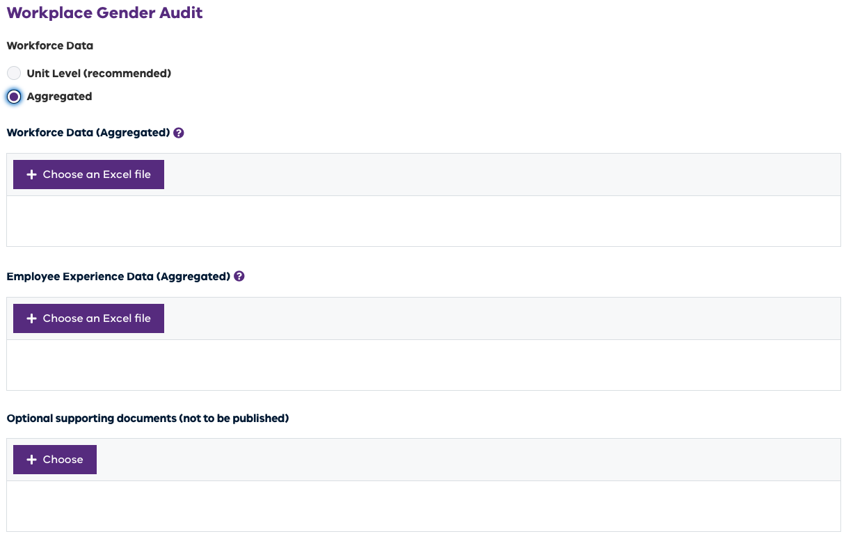

|  |
| --- |
| For this step you will choose your *reporting template for the 2023 employee experience survey*, which you can obtain from the Commission’s website at [Prepare for the employee experience survey 2023 | Commission for Gender Equality in the Public Sector](https://www.genderequalitycommission.vic.gov.au/prepare-employee-experience-survey-2023) |

1. In the file selection pop-up window, select the employee experience reporting template containing the results of your employee experience survey and click “Open”.
2. Once file has loaded (i.e., “Loading…” message is no longer displayed on screen), you will see the Employee Experience Data (Aggregated) section populated with “Results” as indicated in the following figure

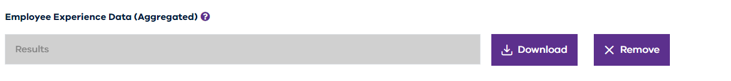

|  |
| --- |
| If you experience an error, refer to Appendix C – Error messages for guidance. |

### Review your audit data

|  |
| --- |
| The ability to review audit data before submitting it to the Commission is new for 2023. |

Once your audit data has been added to your audit record, you can move the audit into a review state. In this state you will be able to

* Inspect a data quality report which will analyse and provide you with feedback about the state of your audit data.
* Inspect your seven gender equality indicator reports built from your data – and make use of the data to prepare your GEAP or progress report
* Inspect a public report preview – to see how your data will be presented publicly.

1. To move your audit to the Review state, ensure that you have added your workforce data and (if required) employee experience data to your audit record.
2. If you wish to add optional supporting documents for the Commission’s review, scroll to the “Optional supporting documents (not to be published)” section of your audit record, and click “Choose” to select the files you wish to add to your audit record.

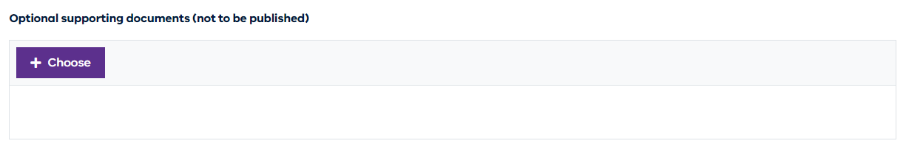

1. In the file selection pop-up window, select up to 10 files and click “Open”. The files will be added to your audit record as indicated below.

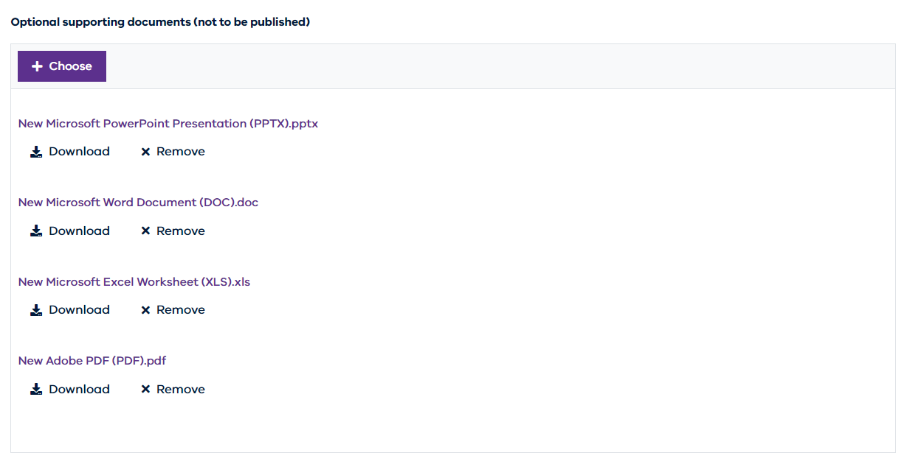

1. When ready to move your audit to a state of Review, click the “Review” button. When completed, you will receive the following message and an email will be issued to all users (refer to Email template – Review (audit only))

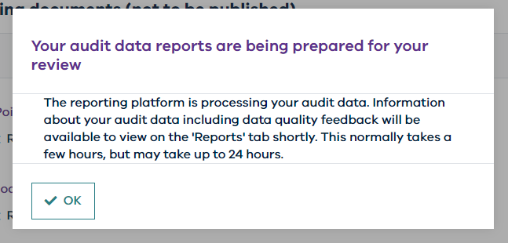

1. Wait for the recommended amount of time indicated in the message before you attempt to access your reports.

|  |
| --- |
| The reporting platform will process your audit data before it is available to review in reports. This typically takes a few hours however at times when there are many demands on the platform, this may take longer.  For information about the reports and how to navigate and make use of them, please refer to Viewing my organisation’s data and reports |

1. If you wish to make further modifications to your audit from this state, you can do so by opening your audit record, scrolling to the action section at the base, and clicking the “Edit” button.

### Submit your workplace gender audit

|  |
| --- |
| Important: You must ensure that you have received appropriate approval from the named person in this section and that proof of approval could be provided if requested. |

Following review of your audit data, you can submit your workplace gender audit for the Commission to review. Once submitted, you will no longer be able to edit your audit.

1. To submit your audit, open your audit record and scroll to the action buttons at the base of the audit.
2. Provide the requested attestation that you have review your quality report and (if appliable) your compliance outcome report – having addressed any feedback that was provided in either report.



1. Provide the requested attestation that your submission is appropriate approved and ensuring you provide your approvers details before clicking “Submit”

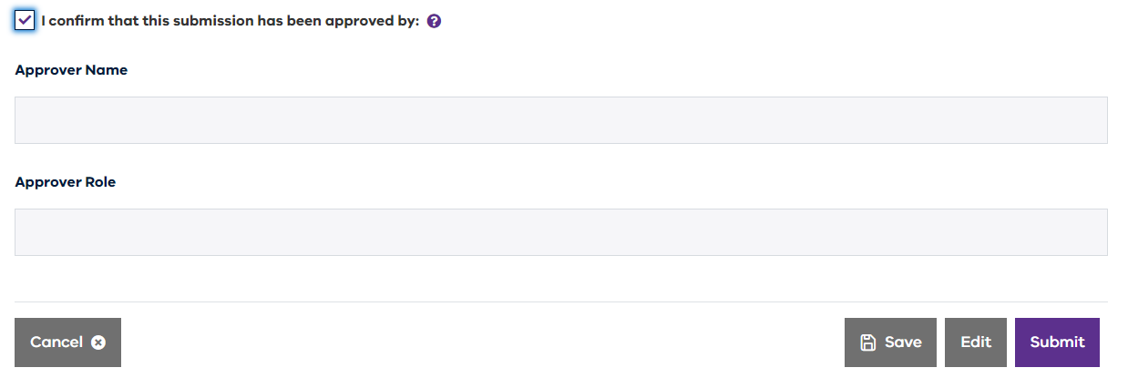

1. Your workplace gender audit results are now officially submitted to the Commission for its review and an email will be issued to your organisation’s users (refer to Email template – Submitted)

### What happens next?

Obligations submitted to the Commission all follow the same process after submission. This process involves the Commission reviewing the obligation to ensure that it meets its requirements under the Gender Equality Act 2020. The outcome of this review may require organisations to update their submitted obligations. For further information, please refer to What happens after I submit my obligation?

# Submitting my organisation’s Gender Equality Action Plan

## How do I submit my GEAP?

### Open your GEAP record

1. On the Obligations dashboard page, locate the row for the Gender Equality Action Plan for the current reporting year.
2. Under the “Actions” column, click on the  icon.

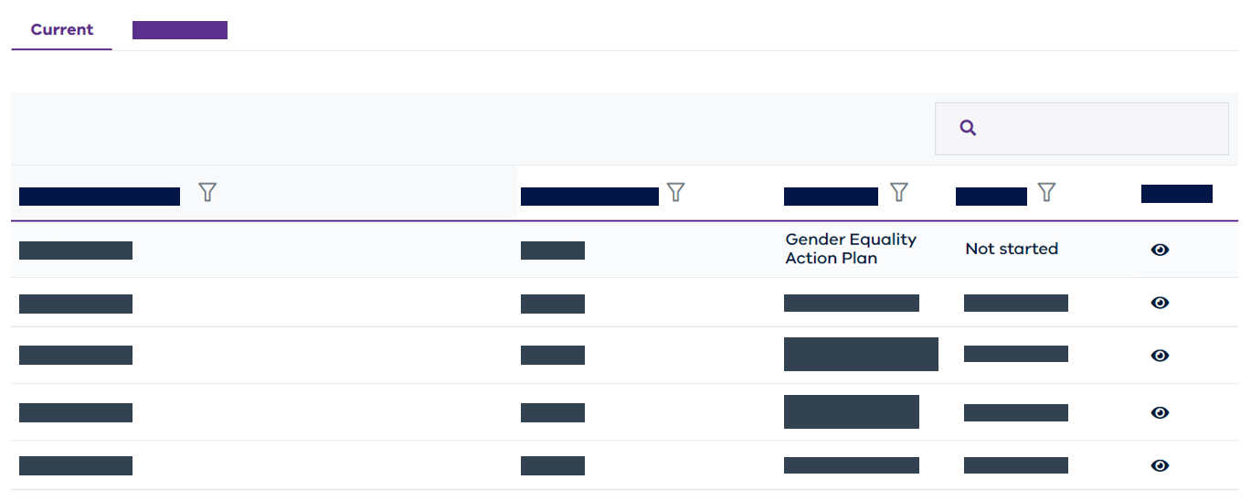

1. Your GEAP record will be opened.

### Upload main Gender Equality Action Plan document

1. Click “+ Choose” in the “Main document (to be published)” section.

1. In the file selection pop-up window, select the file that you would like to upload and click “Open”.
2. Once the file has uploaded (that is, the “Please wait…” message is no longer displayed on screen), you will see the file listed on the screen.

1. Scroll to the bottom of the page and click “Save”. This will save your changes, not submit your obligation. To submit, see section Submit Gender Equality Action Plan

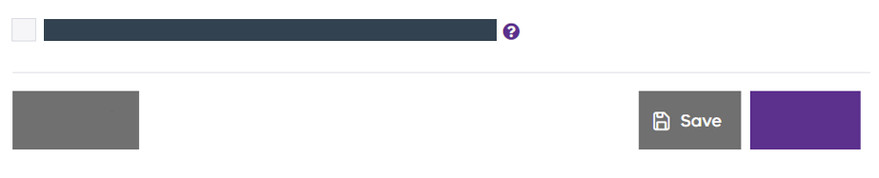

### Upload optional supporting documents

Supporting documents may be uploaded along with your main Gender Equality Action Plan. There are two types of supporting documents that can be uploaded:

* **To be published** (to be made available for the public to view on the public [Insights website](https://insights.commissionforgenderequality.vic.gov.au/)), or
* **Not to be published** (provided only for the Commission to view when reviewing your Gender Equality Action Plan and not to be made available on the public [Insights website](https://insights.commissionforgenderequality.vic.gov.au/))

There are two distinct areas on the upload screen for you to upload your supporting documents to.

Important: Make sure you upload your supporting documents into the correct area.

1. Click “+ Choose” in the appropriate support document section.

1. In the file selection pop-up window, select one or more files (up to a maximum of 10 files) that you would like to load and click “Open”.
2. Once the file(s) have loaded (that is, the “Please wait…” message is no longer displayed on screen), you will see the files listed on the screen.

1. Scroll to the bottom of the page and click “Save”. This will save your changes, not submit your obligation. To submit, see section Submit Gender Equality Action Plan



### Submit Gender Equality Action Plan

|  |
| --- |
| Important: You must ensure that you have received appropriate approval from the named person in this section and that proof of approval could be provided if requested. |

1. At the bottom of the Gender Equality Action Plan upload page, tick the checkbox confirming that the submission has been approved, along with the name and role or title of the person who has provided this approval. Click “Submit”.

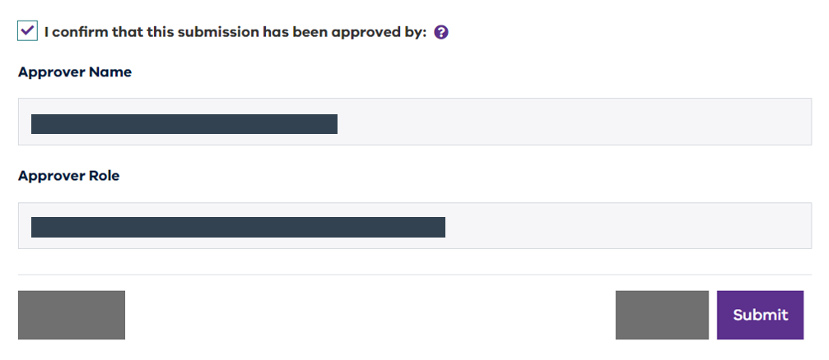

1. You will be prompted with a confirmation pop-up message, click “Yes”.

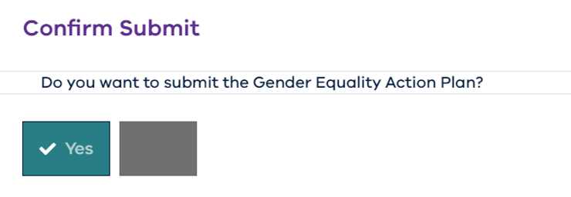

1. Your Gender Equality Action Plan is now officially submitted to the Commission and an email will be issued to your organisation’s users (refer to Email template – Submitted)

### What happens next?

Obligations submitted to the Commission all follow the same process after submission. This process involves the Commission reviewing the obligation to ensure that it meets its requirements under the Gender Equality Act 2020. The outcome of this review may require organisations to update their submitted obligations. For further information, please refer to the section What happens after I submit my obligation?

# Submitting my organisation’s progress report

## How do I submit my progress report?

### Open your progress report record

1. On the Obligations dashboard page, locate the row for the progress report for the current reporting year.
2. Under the “Actions” column, click on the  icon.

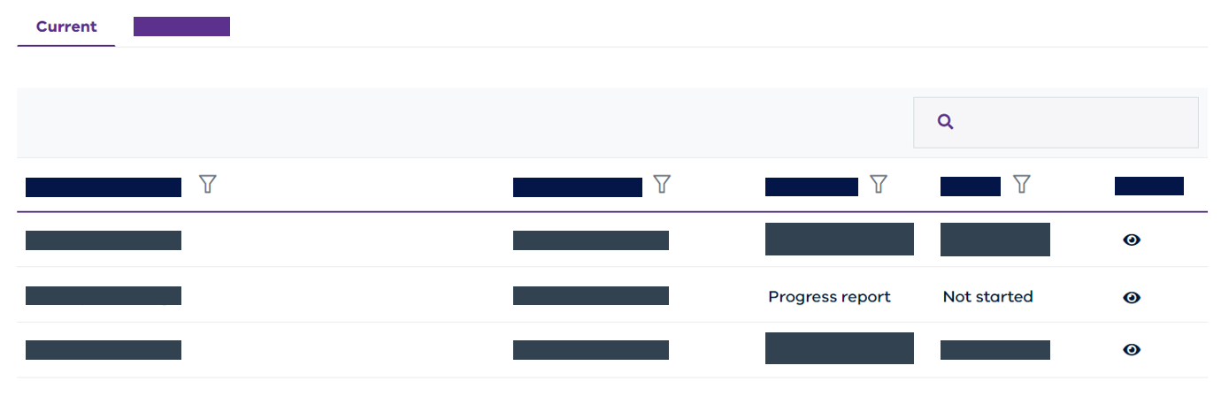

1. Your progress report record will be opened.

### Upload main progress report document

1. Click “+ Choose” in the “Main document (to be published)” section.

1. In the file selection pop-up window, select the file that you would like to upload and click “Open”.
2. Once the file has uploaded (that is, the “Please wait…” message is no longer displayed on screen), you will see the file listed on the screen.

1. Scroll to the bottom of the page and click “Save”. This will save your changes, not submit your obligation. To submit, see section Submit progress report



### Upload optional supporting documents

Supporting documents may be uploaded along with your main progress report document. There are two types of supporting documents that can be uploaded:

* **To be published** (to be made available for the public to view on the public [Insights website](https://insights.commissionforgenderequality.vic.gov.au/)), or
* **Not to be published** (provided only for the Commission to view when reviewing your Gender Equality Action Plan and not to be made available on the public [Insights website](https://insights.commissionforgenderequality.vic.gov.au/))

There are two distinct areas on the upload screen for you to upload your supporting documents to.

Important: Make sure you upload your supporting documents into the correct area.

1. Click “+ Choose” in the appropriate support document section.A screenshot of a phone

   Description automatically generated with low confidence
2. In the file selection pop-up window, select one or more files (up to a maximum of 10 files) that you would like to load and click “Open”.
3. Once the file(s) have loaded (that is, the “Please wait…” message is no longer displayed on screen), you will see the files listed on the screen.

1. Scroll to the bottom of the page and click “Save”. This will save your changes, not submit your obligation. To submit, see section Submit progress report



### Submit progress report

|  |
| --- |
| Important: You must ensure that you have received appropriate approval from the named person in this section and that proof of approval could be provided if requested. |

1. At the bottom of the progress report upload page, tick the checkbox confirming that the submission has been approved, along with the name and role or title of the person who has provided this approval. Click “Submit”.



1. You will be prompted with a confirmation pop-up message, click “Yes”.

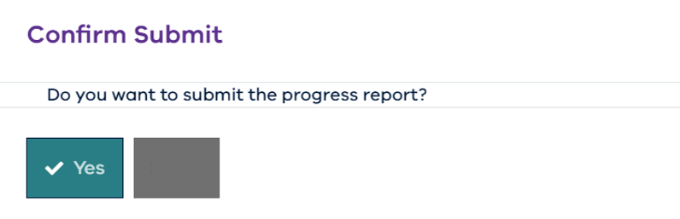

1. Your progress report is now officially submitted to the Commission and an email will be issued to your organisation’s users (refer to Email template – Submitted)

### What happens next?

Obligations submitted to the Commission all follow the same process after submission. This process involves the Commission reviewing the obligation to ensure that it meets its requirements under the Gender Equality Act 2020. The outcome of this review may require organisations to update their submitted obligations. For further information, please refer to What happens after I submit my obligation?

# What happens after I submit my obligation?

Once you have submitted your obligation, the Commission will review your submission to ensure it meets its requirements under the Gender Equality Act 2020.

The status of your submission will remain on “*Submitted*” until it is reviewed by the Commission. When it is being reviewed, the status will change to “Checking for compliance”.

Once the Commission has reviewed your submission, the status of your submission will be marked as either:

* “Final” with a compliance outcome of “Compliant” – indicating that your obligation meets the requirements under the Act.
* “Re-submission required” with a compliance outcome of “Action required” – indicating that further action is required by you to ensure that your obligation meets the requirements under the Act.

When an obligation is marked as either “Final” or “Re-submission” required, it may also include compliance feedback.

## What to do if I am required to re-submit my obligation?

When you are required to re-submit your obligation, your organisation’s users will receive an email from the reporting platform (refer to Email template – Re-submission required)

1. Log into the reporting platform and view your list of obligations, navigating to the obligation with a status of “Re-submission required”
2. Open the obligation record by clicking the 👁‍🗨 action.

1. Scroll down to the “Compliance feedback” section and download the feedback document. Review the feedback and address as appropriate. You can contact the Commission for further information if required.

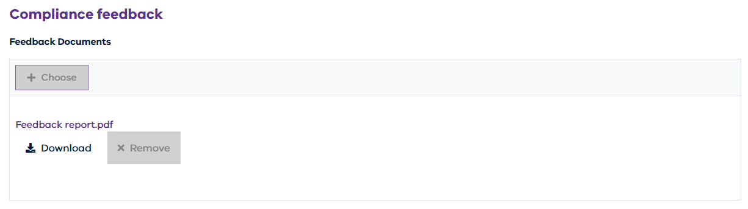

|  |
| --- |
| Feedback documents will remain visible in the obligation as you draft your changes. Once the obligation reaches a status of “Review” (for an audit) or “Submitted” (for all obligations), the feedback documents will no longer be visible within the obligation record.  You can review a previously provided feedback document after an obligation has been re-submitted, by reviewing the “Submission History” of your obligation. Refer to [insert reference to resub history below] |

1. To edit your submission, click “Edit” at the bottom of the page.
2. Then editing your obligation, you may need to remove or add items to your obligation to address the feedback received.
3. Once you have made the necessary changes, review (if applicable) and submit your obligation.

## What to do once my obligation is marked as “Final”?

When your obligation reaches a status of “Final”, your organisation’s users will receive an email from the reporting platform (refer to Email template – Final)

Once your obligation has reached “Final” status, you are not required to take any further action. The Commission may publish your obligations to meet its transparency obligations under the Act via our [Insights Portal](https://insights.genderequalitycommission.vic.gov.au/application-dashboard).

If we publish an obligation, your organisation’s users will receive an email from the reporting platform (refer to Email template – Published)

## I have discovered an error or would like to amend my finalised obligation, how do I do this?

Under the Gender Equality Act (2020), you may request to update a previously submitted Gender Equality Action Plan or previously submitted Workplace Gender Audit results in the reporting platform. For instructions on how to amend a finalised obligation, please refer to Appendix B – Amending a finalised obligation.

# Viewing my organisation’s data and reports

When audit data is uploaded to the reporting platform and the audit is in a status of “Review” or later, the audit data will be made available to you to view in one of four reports

1. The “Indicators” report – which displays your data in the form of gender equality indicator data measures.
2. The “Benchmark” report – which allows you to compare your data across multiple years, or against published benchmarks
3. The “Review” report – which provides a data quality and completeness assessment of your data
4. The “Public (preview)” report – which provides a preview of how your data will be presented on the Insights Portal.

All four reports are available in the “Reports” section of the reporting platform as indicated below

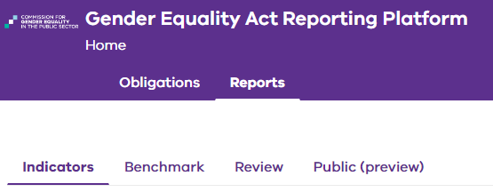

## Using the Indicators report?

The indicators report presents your audit data in the form of gender equality indicator data measures. It is controlled by a series of indicator buttons which will present single page interactive reports for each of the seven gender equality indicators.

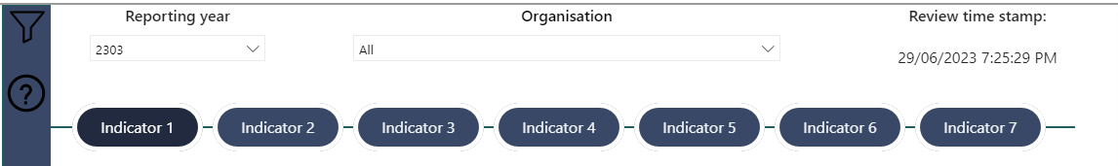

To view and navigate the indicators report, refer to the following steps.

### Selecting the correct audit data

As indicated in the following process flow, there will be a delay between when you move your audit data to a state of “Review” and when that audit data will appear in reports.



Because it can take up to 24 hours to process your data, it is important to check that the data you are viewing in reports is the most recent data that you moved into a state of “Review”

Because the platform may hold both previous and current year audit data, it is also important to check that you are looking at audit data for the correct year.

1. View the header of the Indicators report and look for the “Report year” drop down menu. Ensure that the correct reporting year is selected.
2. In the same header, look for the “Review time stamp”. Ensure that the time stamp matches the time when you moved your audit to a state of “Review”

### Interacting with the data

Interaction controls include the following

**Slicers**

* Slicers are opened from the left hand side of the report by opening the Filter pane which can be accessed by clicking the  filter icon.
* Accessed from the left hand side of the report, slicers allow you to view particular data for more granular analysis
* For example, in the following figure the slicers for indicator 1 are shown below
* They permit refinement of the displayed report data on the following bases
  + Intersectionality – across Aboriginality, Age, Cultural identity, Disability, Religion, Sexual orientation
  + De-identification – by granularity of level to CEO and employment basis, and privacy threshold.
* Each indicator has its own applicable slicers.

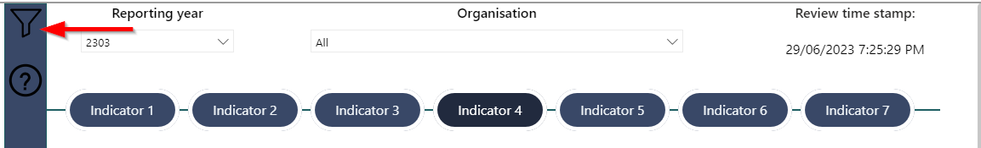

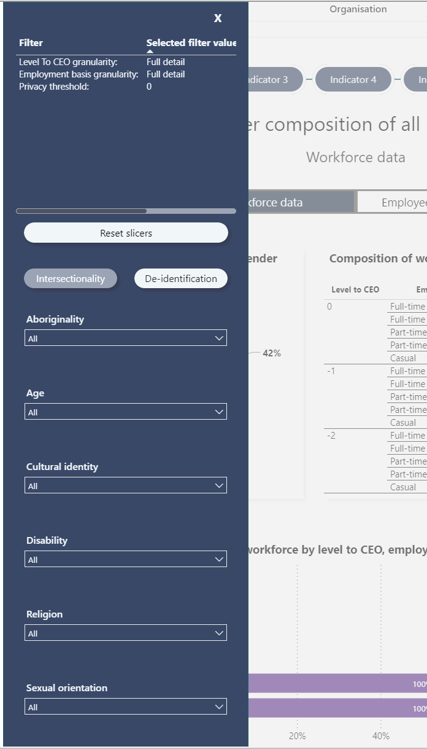

**Data source**

* Some indicators draw their data from workforce data, others from employee experience data, and some will draw data from both.
* Where an indicator provides both workforce data and employee experience data views, use the data control shown in the figure below to select the desired data source.

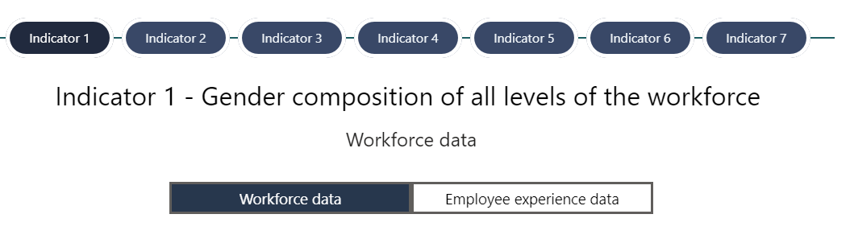

## Using the benchmark report?

* The benchmark reports presents your data in two vertically stacked panels.
* It can used to compare your data against itself, or across multiple years.
* Or it can be used to compare your data against published benchmarks that the Commission has released.

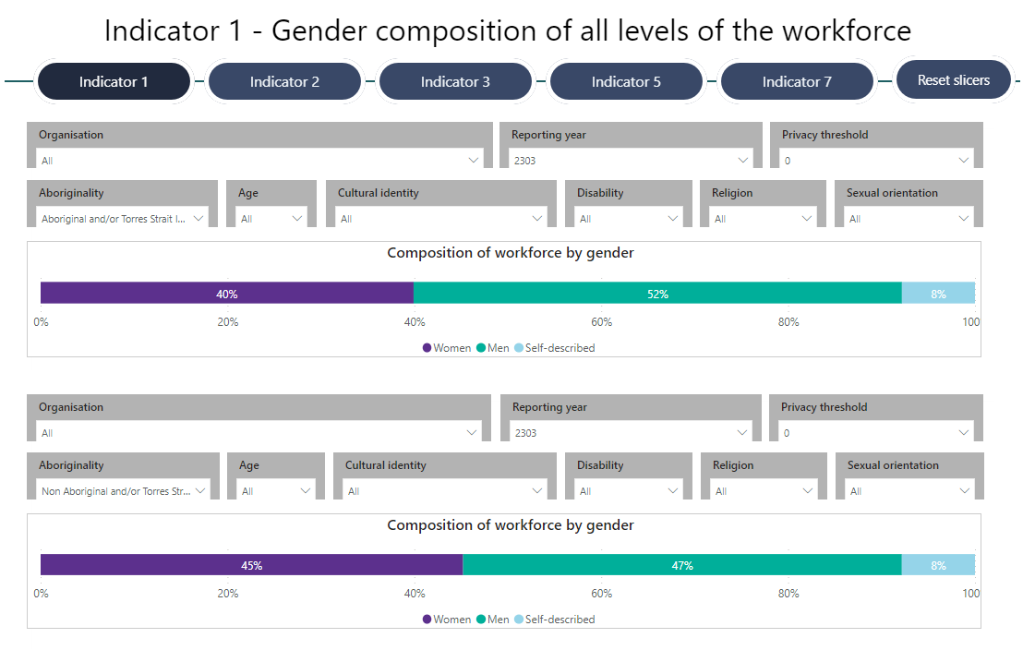

To compare a benchmark, select an indicator and do the following for each panel

1. Select an organisation
   1. You will see will your own organisation and any benchmark organisation. You will not see other public sector organisations.
   2. To compare your data with itself, select your organisation in both panels.
2. Select a reporting year
3. Select a privacy threshold (if required)
4. Select from the available slicers to refine the results you are viewing.
5. View and compare the results between the top and bottom panel.
6. If you need to reset your slicers, use the “Reset slicers” control on the right.

## Using the review report

The review report is used to assess the quality and completeness of your data without needing to submit it to the Commission for review.

When your data is moved to a state of Review, it will become visible in this report (after the requisite delay to process and prepare the data for the report).

The report presents a tabular representation of a set of assessments for your audit data which you can review to take any necessary action before either using your data in your progress report or GEAP, or submitting to the Commission for its review.

### Layout of the report

The review report is organised as a set of five grids, each of which corresponds to one of the five unit level data sets uploaded as part of your audit.

Within each grid, a set of rules is displayed. For each rule the following is displayed

* A rule identifier – which upon clicking will take you to a detailed rule index.
* A description of the rule.
* A result of applying the rule against your data.
* The severity of the issue if your data fails to pass the rule.
* Whether the issue, if not resolved, would be visible to the public when your data is published by the Commission.

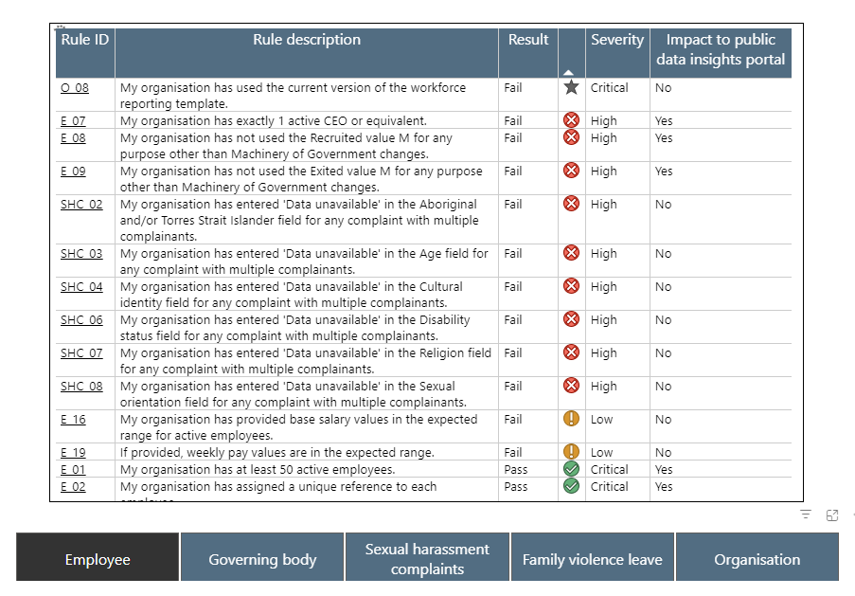

### How to address the report findings

1. View each of the five result sets by clicking each of the five buttons at the base of the report – i.e.
   1. Employee
   2. Governing body
   3. Sexual harassment complaints
   4. Family violence leave
   5. Organisation
2. For each set of results, review the Result column – looking for items where the results = Fail.
3. These items should be reviewed to determine if they can and should be addressed before your audit is submitted.
4. For each “Fail” result, review the detailed review issues index by clicking the Rule ID in the left-most column. This will open the [Progress audit data quality rules 2023 page](https://www.genderequalitycommission.vic.gov.au/progress-audit-data-quality-rules-2023) on the Commission’s website, and take you to the specific rule which the test highlight as being failed.
5. Review the information presented and the advice on what you may need to do to address the issue.
6. Once all issues are address, re-upload your audit data and move it to a state of “Review” again, before inspecting your Review report once more to confirm that you’ve addressed the issues.
7. Repeat this as often as necessary to address all issue you believe can be addressed prior to submitting your audit.

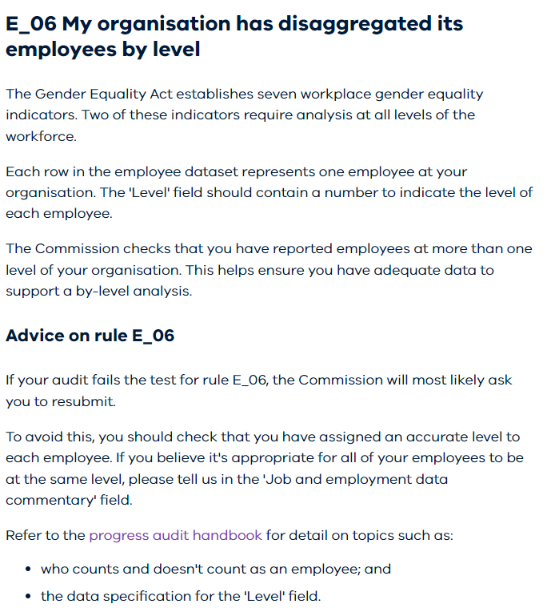

## Using the Public (preview) report

The public preview report will display your data exactly as it will be presented to the public via the [Insights Portal](https://insights.genderequalitycommission.vic.gov.au/application-dashboard).

1. To preview your data, navigate to the public (preview) report
2. Select the reporting year and confirm that you are viewing the most recent version of your audit data by checking the review time stamp.

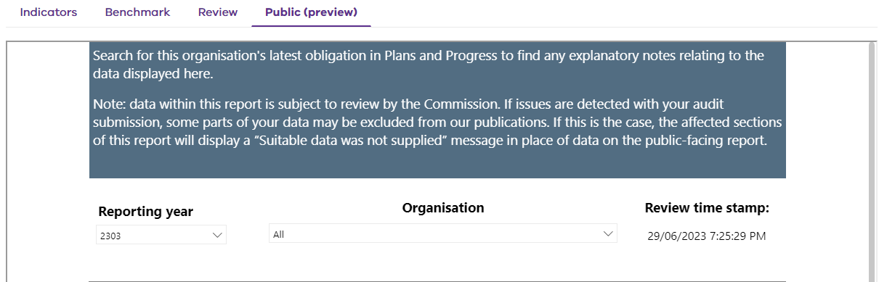

1. Your data will be displayed as it will be presented via the Insights Portal.

# I need help with the reporting platform

## Where can I find additional information about the reporting platform or FAQs?

Navigate to the footer of the reporting platform. There you will find a link to additional information and help within the “Reporting Platform Help” section.



## How do I request help from someone?

You can request help from a support person in the Commission by raising a ticket via the Support Portal.

|  |
| --- |
| Note: the support portal is available only to registered users of the reporting platform. If you are not a registered user of the reporting platform visit <https://www.genderequalitycommission.vic.gov.au/reporting-platform-help> for guidance on how to obtain support. |

### Navigate to the Support Portal

In the footer of the reporting platform, click on the “Raise a support request” link within the “Reporting Platform Help” section.



A new window will open, and you will see one of two screens (depending on your organisation).

**Screen 1:** Your current IT support portal page

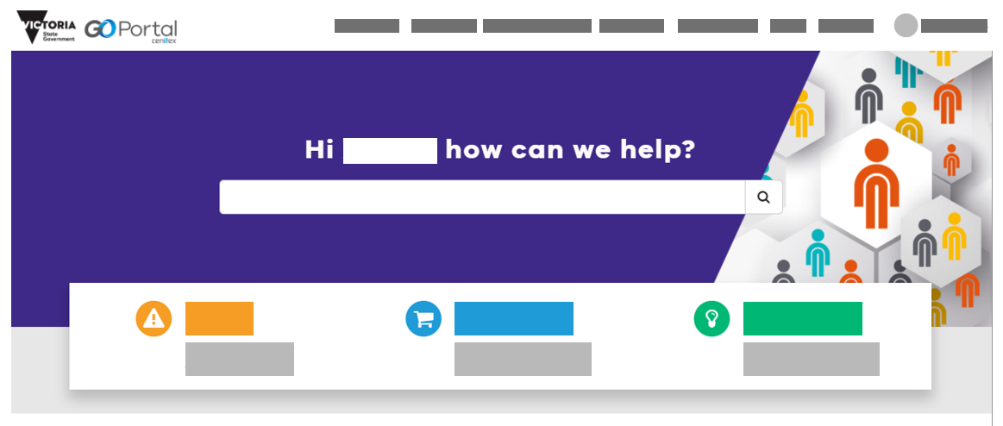

**Screen 2:** A Commission for Gender Equality in the Public Sector specific support portal page

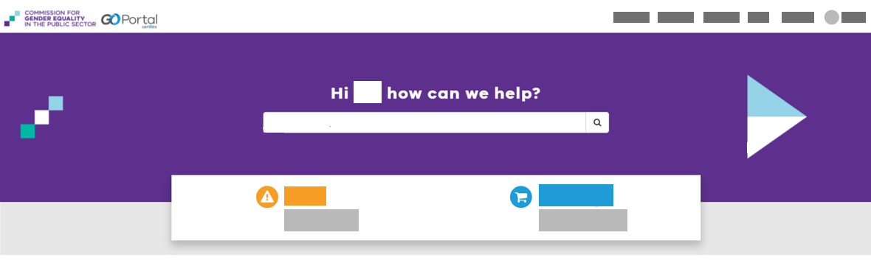

If you see screen 1, refer to section “**Raise a support ticket through my organisation’s Support Portal**” (see section 8.2.2). If you see screen 2, refer to section “**Raise a support ticket through the Reporting Platform Support Portal**” (see section 8.2.3).

### Raise a support ticket through my organisation’s Support Portal

In the main search box, type in “CGEPS” and click on the search (magnifying glass) icon.

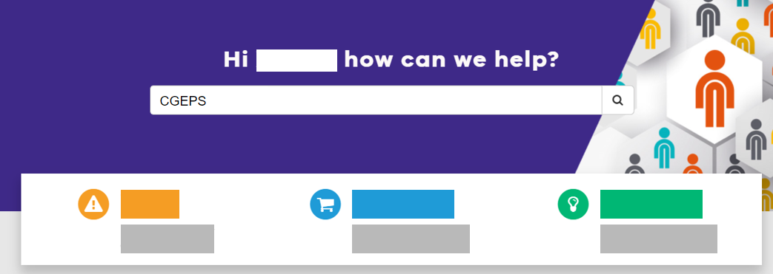

On the search results screen, you will see the following two options:

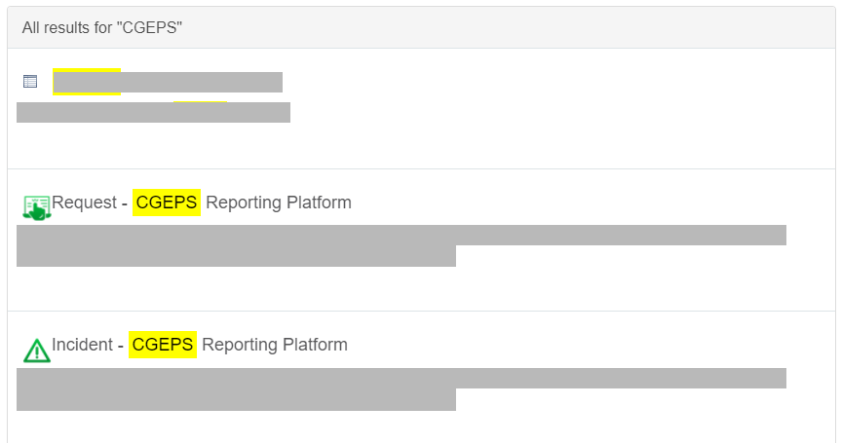

To raise a request for something new or a change to something existing:

1. Click on ‘Request – CGEPS Reporting Platform’
2. Proceed to section “***Requesting for something new or to be changed***”.

To raise a request to fix something broken:

1. Click on ‘Incident – CGEPS Reporting Platform’
2. Proceed to section “***Requesting to fix something broken***”.

### Raise a support ticket through the Reporting Platform Support Portal

On the Support Portal home page, you will see two main options.



To raise a request for something new or a change to something existing:

1. Click on ‘I need something New/Changed’
2. Proceed to section “***Requesting for something new or to be changed***”.

To raise a request to fix something broken:

1. Click on ‘Something is Broken’
2. Proceed to section “***Requesting to fix something broken***”.

### Requesting for something new or to be changed

On the request screen, enter all required information.

|  |  |
| --- | --- |
| **Field** | **Description** |
| Requested for | Automatically populated with your name but can be changed, if raising ticket on behalf of another person |
| Best contact email | Email for the person who the ticket is raised for (either yourself or someone else) |
| Business phone | Phone number to contact the person who the ticket is raised for |
| Mobile phone | Mobile number to contact the person who the ticket is raised for |
| From organisation? | Select your organisation from the drop down list |
| Short description of your request | A summary of your request in a few words |
| Type of request? | Select option from drop down (or if option is not available, select “Other” and provide extra information in the following field |
| What can we help you with? | Enter as much detail as possible to allow the support person to understand what you need assistance with. |
| Add attachments | You may also choose to add attachments. Do not attach any sensitive or confidential information. |

Click ‘Submit’.

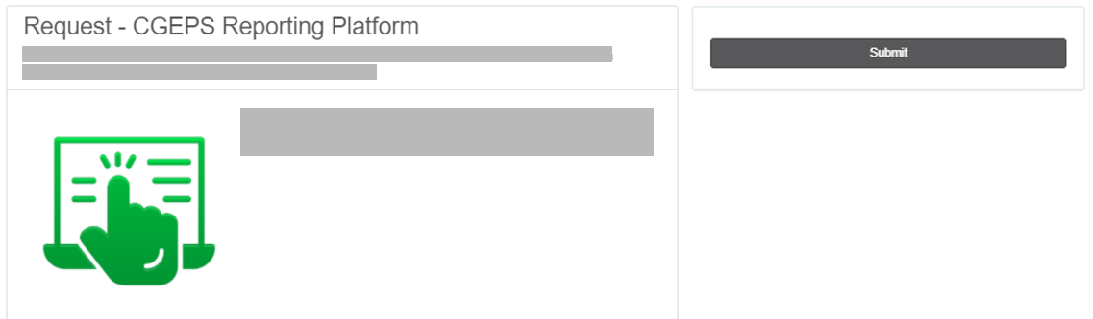

Once submitted, you will see an order status screen. You may choose to take note of the “REQ” number for follow-up purposes if required.

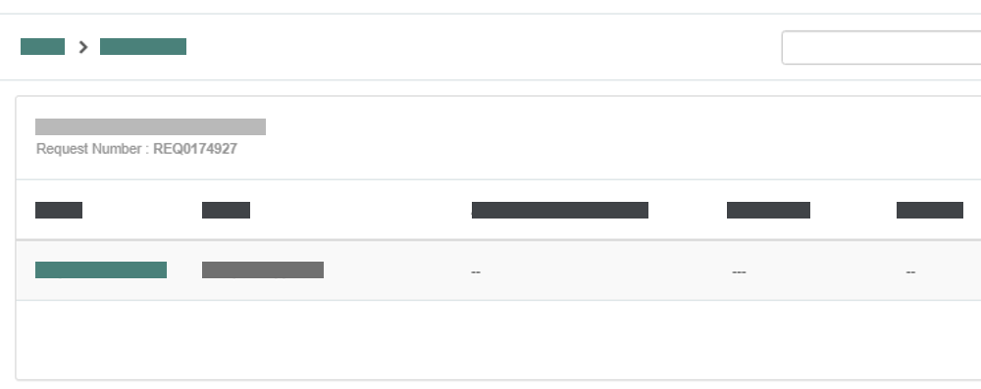

### Requesting to fix something broken

On the incident screen, enter all required information.

|  |  |
| --- | --- |
| **Field** | **Description** |
| Requested for | Automatically populated with your name but can be changed, if raising ticket on behalf of another person |
| Best contact email | Email for the person who the ticket is raised for (either yourself or someone else) |
| From organisation? | Select your organisation |
| Subject | Short description of the incident |
| Type of fault | Select option from drop down (or if option is not available, select “Other” and provide extra information in the following field |
| Please describe the fault | Enter as much detail as possible to allow the support person to understand what you need assistance with. Examples include:   * What process were you trying to complete? * What screen were you on? * What obligation and reporting year were you submitting? |
| Add attachments | You may also choose to add attachments (such as screenshots of error messages). Do not attach any sensitive or confidential information. |

Click ‘Submit’.

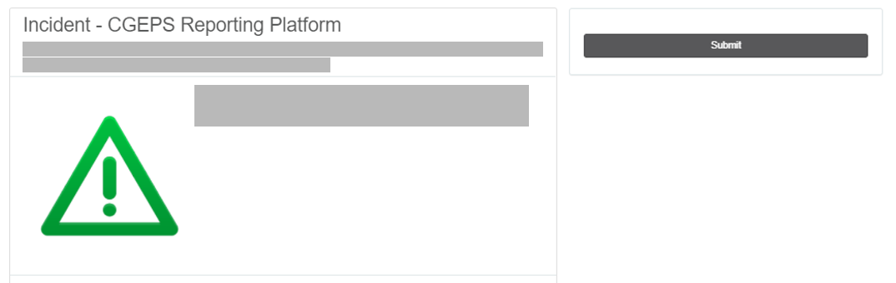

Once submitted, you will see a ticket form screen. You may choose to take note of the “INC” number for follow-up purposes if required.

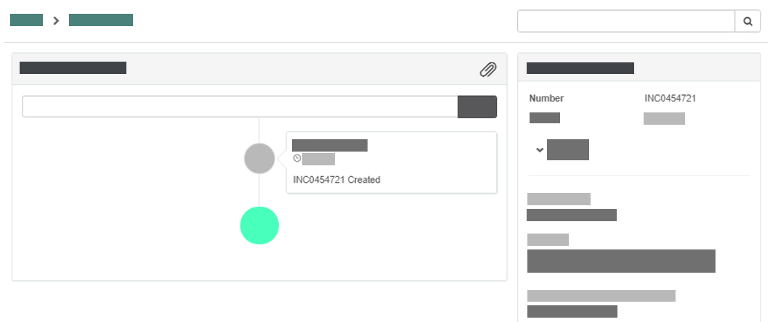

# Appendices

## Appendix A – Requesting access to the reporting platform

1. Raise access request with the Commission

To request access to the reporting platform, you can raise a request using our user onboarding form (below). The form can only be used by the reporting process owner. If you don't know who your organisation's reporting process owner is, please raise a support request and the Commission will let you know.

**https://forms.office.com/r/70cdLhxDG6**

1. Wait for email correspondence from the Commission

Once your access request has been submitted, you will receive an email from the Commission’s enquiries mailbox providing you with an overview of the process for registering your account.

You’ll then receive a second email from a system called the DHHS *User Management Portal* (this step is also described in the overview email). It will advise that you have been granted access to the application “CGEPS” and provide a link to either finalise your account (if you are not already known to the portal), or a link to the CGEPS application (this is the reporting platform).

Click “Finalise your account” (if applicable).

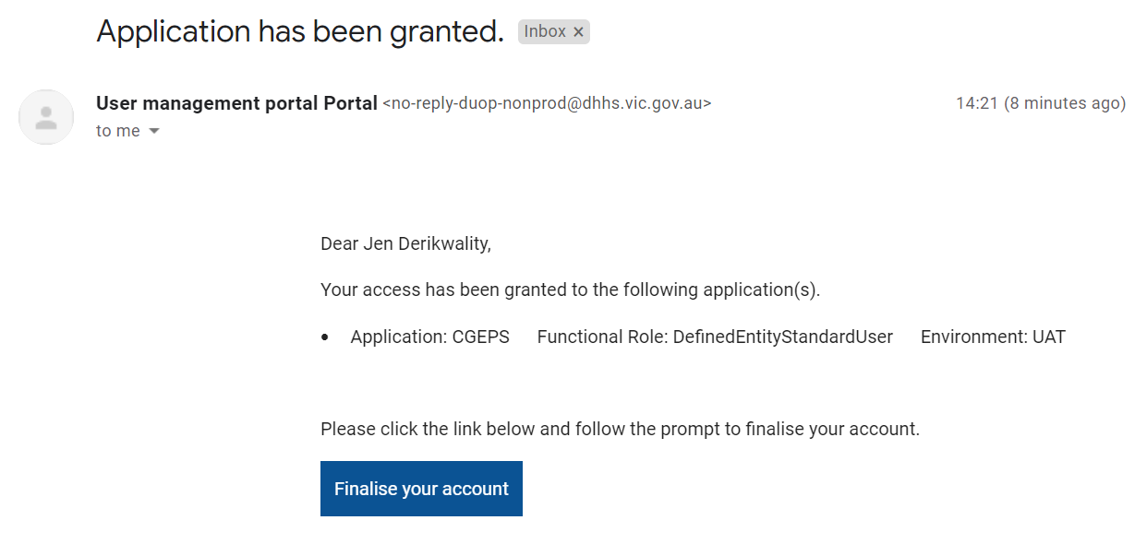

You may be prompted with the following pop-up, click “Proceed”.

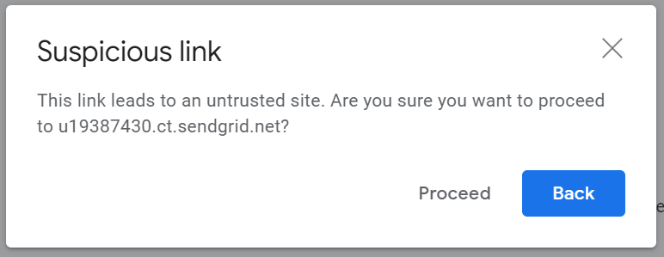

You will be prompted to create an account. This is the account that you will use to log in to the reporting platform. Click “Next”.

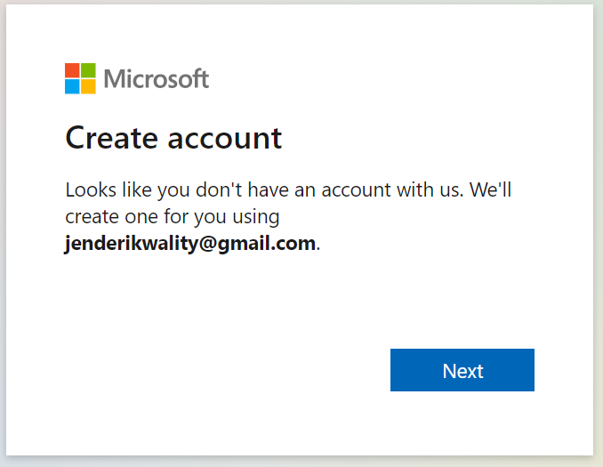

Create a strong password and click “Next”.

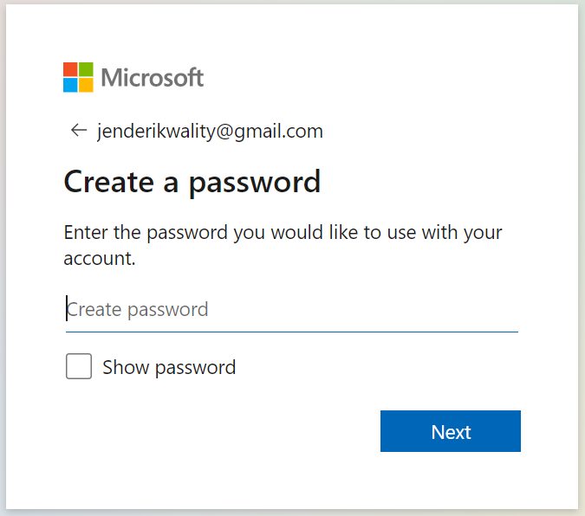

You will be asked to verify your email.

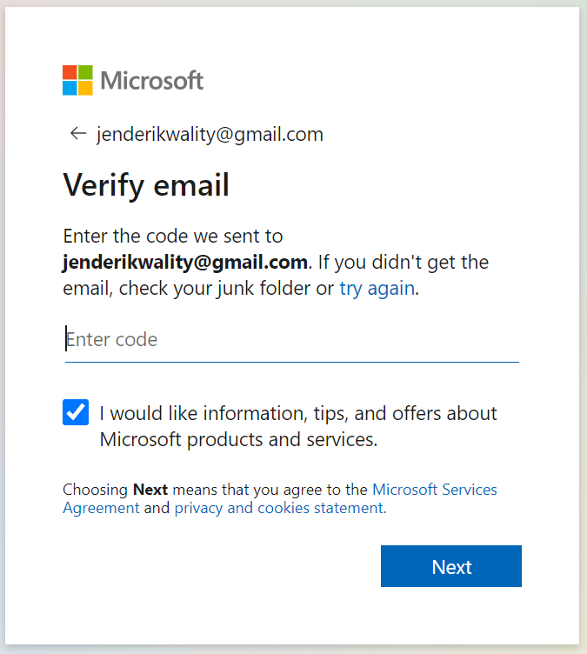

Log in to the email address that you registered with and look for an email from *Microsoft account team (*[*account-security-noreply@accountprotection.microsoft.com*](mailto:account-security-noreply@accountprotection.microsoft.com)*)* with the subject *“Verify your email address”*.

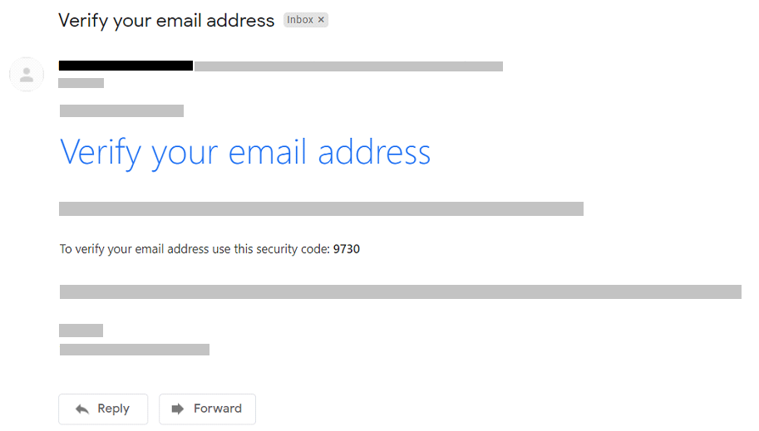

Copy the security code from the email and paste it into the previous “Verify email” screen. Click “Next”.

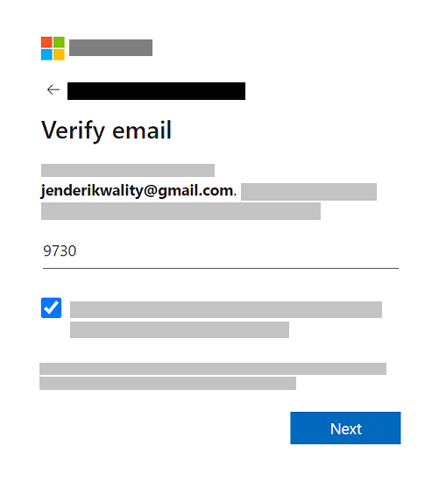

You may be prompted with a security request to verify that you are not a robot. Click “Next” and solve the puzzle as required.

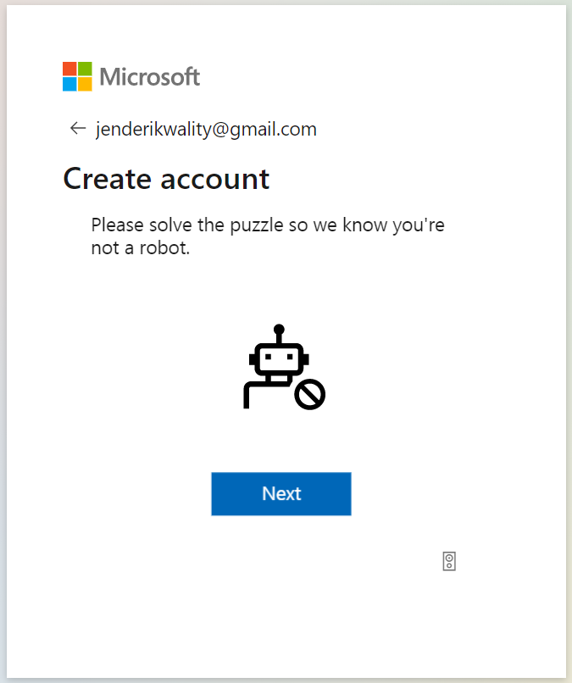

You may choose to stay signed into the reporting platform so that you do not have to continue to enter your login credentials each time.

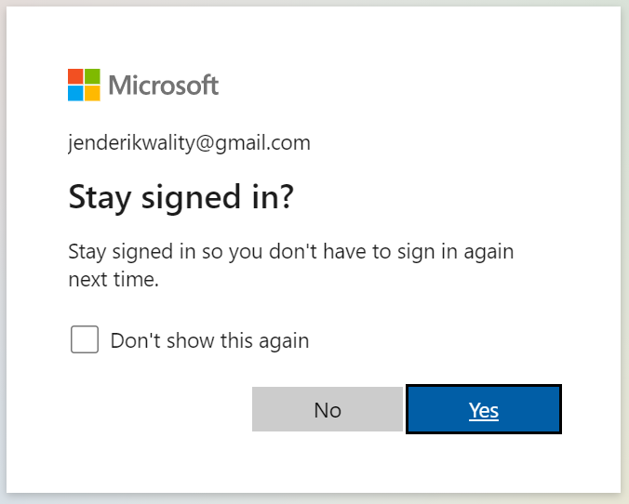

You will be asked to grant permission to be logged in to the reporting platform through DUOP. Click “Accept”.

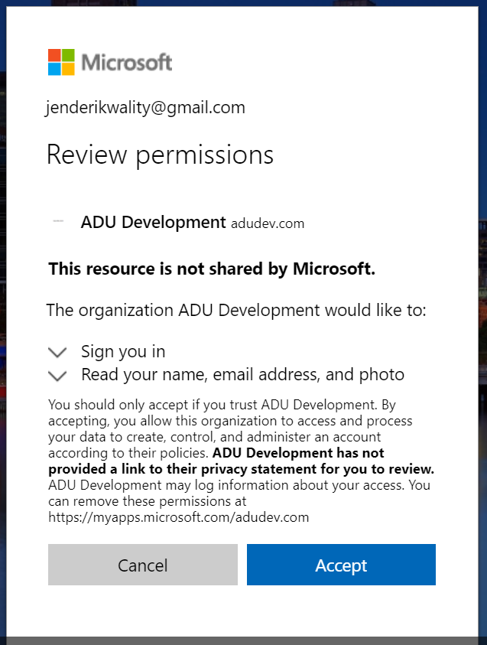

Once all previous verification steps are successful and complete, you will be taken to the reporting platform home page at <https://report.genderequalitycommission.vic.gov.au/application-dashboard>

If you see an error message at this point, your account may not yet be linked to your organisation. The Commission is likely to be completing this step at around the same time as you are attempting to access the reporting portal. Please wait for 30 minutes and try again. If you still receive an error, please raise a support request.

## Appendix B – Amending a finalised obligation



If you have discovered an error in a submission that has a “Final” status or you would like to amend the submission, you will see a “Request re-submission” button in the bottom right-hand corner of the obligation.

Before you click the button, you will need to describe your reason for re-submission and to tick the box that confirms you are authorised to make the re-submission.

Upon clicking the “Update” button, you will be asked for confirmation to amend the submission. Click “Yes”.

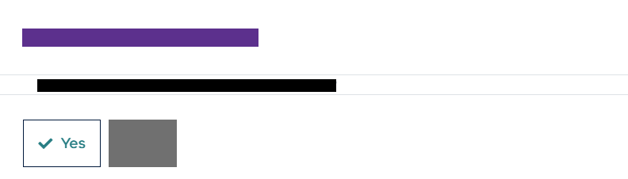

You will receive an email notification once the Commission has enabled the amendment of your finalised submission.

If you have made a mistake with submitting a re-submission request, you can cancel it by clicking “Cancel request” at the bottom of the page.

Upon following the steps in the email, you will find your previously finalised obligation in the “Submission history” tab of the obligations dashboard.

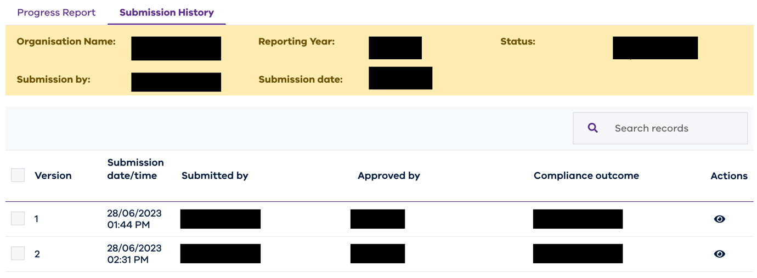

Once the Commission has approved your request for re-submission, the status of your submission will change to “Re-submission required”. Select the obligation to edit and follow the same process as submitting your obligation to re-submit your obligation.

## Appendix C – Error messages

This section outlines the various error messages that you may see when using the reporting platform, along with the recommended steps to take to resolve the error.

To quickly find a specific error message, simply use the “ctrl + F” function in this document to find the error phrase shown in the pop-up message on the reporting platform.

### Errors when uploading workplace gender audit data

#### No value found in cell (unit level workforce data only)

|  |  |
| --- | --- |
|  | |
| What does it mean? | Your unit level data is missing an expected mandatory value. |
| How do I fix it? | Navigate to the cell in your audit template as specified by the error message and populate the missing value. Re-attempt to upload again, using your newly corrected audit template. |

#### No value found in cell (aggregated employee experience data only)

|  |  |
| --- | --- |
|  | |
| What does it mean? | Your aggregated employee experience data is missing an expected mandatory value. |
| How do I fix it? | Navigate to the cell in your AEED spec as specified by the error message and populate the missing value. If the value was intentionally left blank to signify no or insufficient responses received, ensure there is an “N” populated in the cell. Re-attempt to upload again, using your newly corrected AEED spec file. |

#### Invalid value found in cell (unit level workforce data only)

|  |  |
| --- | --- |
|  | |
| What does it mean? | Your unit level data contains a value that is not considered an acceptable list value. |
| How do I fix it? | Navigate to the cell in your audit template as specified by the error message and refer to the “Acceptable values” worksheet to determine an appropriate replacement or action. Re-attempt to upload again, using your newly corrected audit template. |

#### File does not contain a mandatory worksheet (unit level workforce data only)

|  |  |
| --- | --- |
|  | |
| What does it mean? | Expected worksheet is not present in the file being uploaded or an incompatible file type was uploaded. |
| How do I fix it? | Ensure you are using the audit template as supplied by the Commission to upload your workplace gender audit data. |

#### No worksheet named “DataMeasuresForUpload” was found in the file (aggregated workforce data only)

|  |  |
| --- | --- |
|  | |
| What does it mean? | Expected worksheet is not present in the file being uploaded or an incompatible file type was uploaded. |
| How do I fix it? | Ensure you are using the audit template as supplied by the Commission to upload your workplace gender audit data. |

#### No worksheet name “Results” was found in the file (aggregated employee experience data only)

|  |  |
| --- | --- |
|  | |
| What does it mean? | Expected worksheet is not present in the file being uploaded. |
| How do I fix it? | Ensure you are using the AEED spec as supplied by the Commission to upload your workplace gender audit data. |

#### No data rows found from row 2 onwards (unit level workforce data only)

|  |  |
| --- | --- |
|  | |
| What does it mean? | A file without the ‘Employee’ worksheet was attempted to be uploaded into the ‘Unit level (recommended)’ section. |
| How do I fix it? | Populate the ‘Employee’ worksheet in your audit template and re-upload it. |

#### No data rows found from row 3 onwards (aggregated workforce data only)

|  |  |
| --- | --- |
|  | |
| What does it mean? | A file without aggregated workforce data populated was attempted to be uploaded into the ‘Workforce Data (Aggregated)’ section. |
| How do I fix it? | Populate the aggregated workforce template and re-upload it. |

#### Header not found (aggregated employee experience data only)

|  |  |
| --- | --- |
|  | |
| What does it mean? | Columns in the file that was attempted to be uploaded into the ‘Employee Experience Data (Aggregated)’ section do not match the expected columns in the AEED spec provided by the Commission. |
| How do I fix it? | Ensure you are using the AEED spec as supplied by the Commission to upload your workplace gender audit data. |

#### Internal Server Error

|  |  |
| --- | --- |
|  | |
| What does it mean? | User has uploaded a file and is attempting to download it again before saving the Workplace Gender Audit form. |
| How do I fix it? | Save your Workplace Gender Audit first, then download the required file. |

#### Header partially missing in row 2 (aggregated workforce data only)

|  |  |
| --- | --- |
|  | |
| What does it mean? | User has downloaded the aggregated workforce data from their Workplace Gender Audit and is re-attempting to upload the file. |
| How do I fix it? | Do not edit the download file but rather the original audit template used when first uploading your aggregated workforce data and then re-attempt your upload. |

## Appendix D – Emails generated by the reporting platform

The reporting platform will issue email to all users from an organisation when an obligation is moved between any of the following states

1. From **Drafting** to **Review** (for an audit)
2. From **Review** to **Submitted** (for an audit)
3. From **Drafting** to **Submitted** (for a GEAP or progress report)
4. From **Submitted** to **Checking for Compliance** (for all obligations)
5. From **Checking** **for** **Compliance** to **Final** (for all obligations)
6. From **Checking for Compliance** to **Re-submission required** (for all obligations)
7. From **Final** to **Re-submission required** (for all obligations)
8. From **Final** to **Published** (for all obligations)
9. From **Published** to **Final** (for all obligations)

Additionally, email will be generated when a user is added to the reporting platform and associated to an organisation.

### Email template – Review (audit only)

|  |
| --- |
| Subject: [Gender Equality Act Reporting Platform] For action: Your workplace gender audit has been moved to review.  Dear <Organisation Name>,  This email has been issued to advise that your workplace gender audit data was moved to the review stage on <review date dd/mm/yyyy> at <review time hh:mm AM/PM> and your data will be ready for viewing in reports on the reporting platform shortly.  **What do you need to do?**  Information about your audit data including data quality feedback will be available through the reporting platform shortly. Processing normally takes a few hours, but may take up to 24 hours. At that time, please log in to the reporting platform and navigate to the 'Reports' tab. In this area, you'll find tools to help you:   * + Review potential issues with your audit data   + View your organisation's most recent audit results   + Compare results and measure progress over time   + Preview how your results will look in the Commission's public-facing Insights Portal   For further information or to request assistance please refer to the links in the footer below. |

### Email template – Submitted

|  |
| --- |
| Subject: [Gender Equality Act Reporting Platform] For information: Your Gender Equality Action Plan has been submitted.  Dear <Organisation Name>,  This email has been issued to advise that your Gender Equality Action Plan for the current reporting year has reached a status of ‘Submitted’.  **What do you need to do?**  This email is provided for information and no action is required from you at this stage.  **What will happen next?**  The Commission for Gender Equality in the Public Sector will commence reviewing your Gender Equality Action Plan shortly to ensure it fulfills its requirements under the Gender Equality Act. The outcome of the review may require you to provide additional information, in which case the Commission will contact you regarding the actions required.  For further information or to request assistance please refer to the links in the footer below. |

### Email template – Checking for Compliance

|  |
| --- |
| Subject: [Gender Equality Act Reporting Platform] For information: Your Gender Equality Action Plan is being checked for compliance.  Dear <Organisation Name>,  This email has been issued to advise that your Gender Equality Action Plan for <reporting year> has reached a status of ‘Checking for compliance’.  **What do you need to do?**  This email is provided for information and no action is required from you at this stage.  **What will happen next?**  The Commission for Gender Equality in the Public Sector will notify you of the outcome of the review shortly. Should the outcome of the review require you to provide additional information, the Commission will contact you regarding the actions required.  For further information or to request assistance please refer to the links in the footer below. |

### Email template – Final

|  |
| --- |
| Subject: [Gender Equality Act Reporting Platform] For action: Your Gender Equality Action Plan submission has been finalised.  Dear <Organisation Name>,  This email has been issued to advise that your Gender Equality Action Plan for <reporting year> has reached a status of ‘Final’.  **What do you need to do?**  No further action is required in relation to the submission of your Gender Equality Action Plan. Review the Gender Equality Act requirements to determine if and when you need to publish finalised documents on your organisation’s website. Personal and identifying information must be removed prior to publication.  **What will happen next?**  The Commission for Gender Equality in the Public Sector will keep a record of your Gender Equality Action Plan in its register of Gender Equality Action Plans and may also publish your Gender Equality Action Plan on its website. Personal and identifying information will be removed prior to publication.  For further information or to request assistance please refer to the links in the footer below. |

### Email template – Re-submission required

|  |
| --- |
| Subject: [Gender Equality Act Reporting Platform] For action: Your Gender Equality Action Plan requires re-submission.  Dear <Organisation Name>,  This email has been issued to advise that your Gender Equality Action Plan for <reporting year> has reached a status of ‘Re-submission required’.  **What do you need to do?**  The Commission for Gender Equality in the Public Sector has completed a review of your recently submitted Gender Equality Action Plan and requires additional information or clarification in relation to your submission.  **What will happen next?**  Please log in to the reporting platform to view your submission. There you will find feedback comments on how to ensure your Gender Equality Action Plan fulfills its requirements under the Gender Equality Act.  For further information or to request assistance please refer to the links in the footer below. |

### Email template – Published

|  |
| --- |
| Subject: [Gender Equality Act Reporting Platform] For information: Your <obligation> has been published.  Dear <Organisation Name>,  This email has been issued to advise that the Commission for Gender Equality in the Public Sector, through its functions under the Gender Equality Act, has published your finalised <obligation> into the register of plans and reports on its Insights website (insights.genderequalitycommission.vic.gov.au).  **What do you need to do?**  No further action is required in relation to the submission of your <obligation>. If you have not already done so, review the Gender Equality Act requirements to determine if and when you need to publish finalised documents on your organisation’s website. Personal and identifying information must be removed prior to publication.  For further information or to request assistance please refer to the links in the footer below. |

### Email template – Unpublished

|  |
| --- |
| Subject: [Gender Equality Act Reporting Platform] For information: Your <obligation> has been unpublished.  Dear <Organisation Name>,  This email has been issued to advise that your finalised <obligation> has been removed from the Commission for Gender Equality in the Public Sector’s Insights website (insights.genderequalitycommission.vic.gov.au).  This may have been at your organisation's or because the Commission has determined it is necessary.  **What do you need to do?**  You do not need to take action specifically in response to this notification. However, if you are not sure of the reason for the removal please contact the Commission using the links in the footer below. |

### Email template – User added to organisation

|  |
| --- |
| Subject: [Gender Equality Act Reporting Platform] Welcome <User Firstname> <User Lastname>.  Dear <User Firstname> <User Lastname>,  Your account has been set-up and granted access to <Organisation> with the role of <User Role>.  You may have also received an email from DHHS User Portal requesting you to finalise your account. Please ensure you have completed this action before accessing the reporting platform at the link shown in the footer of this email. |

# Version History

|  |  |  |
| --- | --- | --- |
| **Version** | **Date** | **Changes** |
| v0.1 | 01/09/2021 | Initial draft. |
| v1.0 | 08/11/2021 | Final version to support Reporting Platform Release 1. |
| v1.1 | 10/11/2021 | Disabled track changes and amended references to section ‘What happens after I submit my obligation?’. |
| V2.0 | 30/6/2023 | Updates for the June 2023 release of the reporting platform. |