

**Caring and workplace gender equality in the Public Sector in Victoria**

Final Project Report

April 2023



**TABLE OF CONTENTS**

|  |  |
| --- | --- |
| List of Figures | 2 |
| Acknowledgement of Country | 3 |
| Acknowledgements | 3 |
| 1. **Executive Summary** | 4 |
| 1.1 Project Overview | 4 |
| 1.2 Summary of Key Findings | 5 |
| 1.3 Recommendations | 5 |
| 1. **Introduction and Background** | 7 |
| 1. **Summary of Research Approach** | 9 |
| 3.1 Identifying and Sourcing Participants | 9 |
| 3.2 Survey | 9 |
| 3.3 Interviews  3.4 Audit data | 11  12 |
| 1. **Findings and Discussion** | 13 |
| 4.1 Caring Responsibilities | 13 |
| 4.2 Conflicts between Work and Care | 13 |
| 4.3 Flexible Working Arrangements | 14 |
| 4.4.1 Taking Leave: Information Gaps | 18 |
| 4.4.2 Taking Leave: Discrimination, Repercussions and Consequences | 19 |
| 4.4.3 Taking Leave: Inadequate Entitlements | 21 |
| 4.4.4 Taking Leave: Gender Disparities | 22 |
| 4.4.5 Taking Leave: Non-normative Circumstances | 23 |
| 4.4.6 Taking Leave: Fear in asking for entitlements | 24 |
| 4.5 Career Progression | 25 |
| 4.6 Workplace Culture | 28 |
| 4.7 Intersectionality | 30 |
| 4.8 Role Modelling | 30 |
| 1. **Conclusion** | 32 |
| 1. **References** | 33 |

**LIST OF FIGURES**

|  |  |  |
| --- | --- | --- |
| **Figure 1** | Demographic breakdown of survey respondents by gender identity | 9 |
| **Figure 2** | Demographic breakdown of survey respondents by age | 9 |
| **Figure 3** | Demographic breakdown of survey respondents by cultural background | 10 |
| **Figure 4** | Demographic breakdown of survey respondents by employment status | 10 |
| **Figure 5** | Demographic breakdown of survey respondents by top 5 VPS agencies | 11 |
| **Figure 6** | Demographic breakdown of survey respondents by VPS level | 11 |
| **Figure 7** | Demographic breakdown of survey respondents' type(s) of dependents | 13 |
| **Figure 8** | Alternative care arrangements utilised by survey respondents | 13 |
| **Figure 9** | Types of flexible working arrangements utilised by survey respondents | 15 |

## ACKNOWLEDGEMENT OF COUNTRY

The University of Melbourne acknowledges the Traditional Owners of the unceded land on which we work, learn and live: the Wurundjeri Woi-wurrung and Bunurong peoples (Burnley, Fishermans Bend, Parkville, Southbank and Werribee campuses), the Yorta Yorta Nation (Dookie and Shepparton campuses), and the Dja Dja Wurrung people (Creswick campus).

The University also acknowledges and is grateful to the Traditional Owners, Elders and Knowledge Holders of all Indigenous nations and clans who have been instrumental in our reconciliation journey.

We recognise the unique place held by Aboriginal and Torres Strait Islander peoples as the original owners and custodians of the lands and waterways across the Australian continent, with histories of continuous connection dating back more than 60,000 years. We also acknowledge their enduring cultural practices of caring for Country.

We pay respect to Elders past, present and future, and acknowledge the importance of Indigenous knowledge in the Academy. As a community of researchers, teachers, professional staff and students we are privileged to work and learn every day with Indigenous colleagues and partners.

## ACKNOWLEDGEMENTS

The University of Melbourne acknowledges and thanks the Victorian Government and Victorian Commission for Gender Equality in the Public Sector (the Commission) for providing the funding to conduct this research as part of the Commission’s Research Grants Round 2022. We acknowledge the support and assistance of the Commission in undertaking this research, particularly Commissioner Dr Niki Vincent, Dr Kate Farhall and Dr Jessica Megarry.

The University of Melbourne interdisciplinary team undertaking this research was comprised of Associate Professor Alysia Blackham, Professor Leah Ruppanner, Professor Beth Gaze, Professor Susan Ainsworth, Dr Brendan Churchill, Research Project Managers Kate Dangar and Mira Gunawansa, and Research Assistant Lía Acosta Rueda, and Statistical Consultant Cameron Patrick.

**To cite this report:** Kate Dangar, Mira Gunawansa, Alysia Blackham, Leah Ruppanner, Beth Gaze, Susan Ainsworth, Brendan Churchill, Lía Acosta Rueda and Cameron Patrick, *Caring and workplace gender equality in the Public Sector in Victoria: Final Project Report* (University of Melbourne, 2023) DOI: 10.26188/23267684.

# 1. EXECUTIVE SUMMARY

## 1.1 Project Overview

Caregiving has a significant impact on workplace inequality. With over 63% of primary carers in Victoria participating in the workforce (Carers Vic 2021), and as the largest employer in the state, the Victorian Public Sector (VPS) has a responsibility to adequately account for these inequities in their organisational policies.

Drawing on a quantitative survey (n=349) and qualitative interviews (n=74), this report explores the experiences of public sector workers in relation to work and care responsibilities. It identifies barriers and gaps in flexible working arrangements and experiences of taking leave, and makes evidence-based recommendations to advance gender equality for caregivers in the VPS. This report also highlights how caregiving impacts the career progression of women caregivers in particular, as informed and influenced by workplace cultures that perpetuate negative attitudes towards care.

As such, this report critically examines how the VPS can address the ongoing impact caregiving roles can have on the careers and wellbeing of VPS employees. It maps gender disparities in access to, and use of, leave and flexible work, evaluating how the ***Gender Equality Act 2020 (Vic)*** **(GEA 2020)** can better address the impact of caring.

This report critically examines and evaluates:

1. How caring affects the gendered use and impact of organisational policies around leave and flexible work, through a survey of and interviews with public sector employees;
2. Workplace gender audit data around leave and flexible work, to identify gaps, limits and areas for improvement;
3. Points of improvement requiring additional support to facilitate gender equality in the future of caring in the public sector;
4. How flexible work and leave entitlements are being used by men, women and gender non-binary workers; and
5. How public sector agencies, and the **GEA 2020***,* could better address the equality impacts of care work.

This future focused work identifies opportunities for the **GEA 2020’s** ongoing development and implementation to ensure its success.

This report draws on desktop data collection as well as analysis of primary data from 349 survey responses and 74 semi-structured qualitative interviews with public sector employees from 23 VPS departments, agencies, and organisations across Victoria.

## 1.2 Summary of Key Findings

* Workplace flexibility is one of the great strengths of the VPS.
* Women represent the majority of caregivers in the VPS and spend substantially more time on care work than men.
* Access to leave entitlements and flexible working arrangements for carers is highly dependent on individual managers.
* Most respondents have not been made aware of their rights as carers in the workplace.
* Most respondents feel that their leave entitlements are insufficient and are difficult to access.
* Significantly fewer men than women are utilising flexible working arrangements and leave entitlements to balance their work and care responsibilities.
* COVID-19 increased conversations around carers being able to work flexibly, but there is an ongoing push to ‘return to normal’ in the workplace. Carers are anxious that they will not be afforded the same flexibility they currently receive into the future.
* Caregivers are significantly less likely to be offered opportunities for career progression, especially working mothers and mature aged (50+ years) women. The majority of carers surveyed in our survey believe that having a caring responsibility is a barrier to success in their organisation; by contrast, in the **VPSC People Matters Survey** (**PMS**), 59% of women and 62% of men agreed or strongly agreed that caring responsibilities were not a barrier to success. However, only 40% of non-binary respondents agreed or strongly agreed that caring responsibilities were not a barrier to career success. This flags the importance of considering gender differences beyond gender binaries.
* Discrimination against caregivers in the workforce continues to go unaddressed. Carers with intersecting identities are more likely to face discrimination in the workplace on account of their caregiver status.
* People taking leave for traumatic reasons (e.g., miscarriage and domestic violence) are less likely to be provided with adequate or informed support.
* Insecure work exacerbates the problems experienced by carers and may deter carers from making use of their entitlements to leave and flexible work arrangements.

## 1.3 Recommendations

This report makes the following recommendations:

### Recommendations for Public Sector Entities:

* Revise the ***Victorian Public Service Enterprise Agreement 2020*** to adopt an inclusive definition of caregiving. This could be modelled on the *Equal Opportunity Act* (2010) s 4(1) definition of a carer.
* Investigate how caregivers are utilising personal/sick leave, unpaid leave and annual leave for their caregiving responsibilities. Future studies of workplace audit data could be undertaken on this point.
  + Conduct an annual audit to assess whether there are sufficient leave allowances to account for caregiving needs.
* Consider increasing personal and sick leave entitlements for the VPS.
* Make flexible working arrangements the default across the VPS.
* Ensure HR Departments monitor patterns in requests for, and use of, caregiving entitlements and programs.
* Include the provision and effective management of appropriate flexible work arrangements for staff as one of the criteria in the performance appraisal process for managers across the VPS.
* Review the accessibility of information surrounding carers’ rights (i.e. leave entitlements and to flexible work) (e.g. on the VPS intranet). Increase visibility of the diverse types of leave entitlements (Family Violence Leave, Compassionate Leave, etc.) that caregivers have a right to access.
* Mandate relevant training across all VPS levels of management to educate managers about caring and workplace flexibility and existing leave entitlements.

### Recommendations for Managers and HR Departments:

* Promote and publicise managers taking leave and utilising flexible working arrangements to accommodate their caring needs to encourage senior role modelling.
* Integrate discussions about flexibility and flexible work arrangements in regular check-ins with staff.
* Make information regarding leave entitlements clearer and more accessible, so employees in all positions and roles can easily understand and utilise their workplace benefits.
* Review all forms of leave entitlements for information accessibility and sufficiency.
* Encourage and advocate for caregivers applying for career advancement opportunities.
* Establish peer-led networks for carers, to share information and provide a support network for those with caring responsibilities in the VPS.
* Develop better supports for those returning to work after a period of caregiving leave.

### Recommendations for the Commission for Gender Equality in the Public Sector (CGEPS):

* Continue to scrutinise the use of insecure and temporary work arrangements in the VPS, and the extent to which these arrangements disproportionately affect those with caring responsibilities.
* Encourage organisational data collection that captures the diversity of caregiving responsibilities among staff.

# INTRODUCTION AND BACKGROUND

2.65 million Australians provide care to children, parents, relatives, neighbours, and community members every single day. In Victoria alone, 11% of the population are carers (Carers Vic 2021). Caregiving roles and responsibilities are diverse and can alter across the life course of a caregiver and their dependant(s).

For many, caregiving responsibilities can occur at multiple times throughout their life. Such care can take many forms, including domestic work and physical tasks. However, under-recognised and undervalued forms of care also include emotional labour and varying mental loads. Some of these caring responsibilities are predictable and can be anticipated in advance; others are less predictable and require immediate attention. As a result, the nature of caregiving can alter in type, intensity, length of time, and level of support available to the dependant outside of the home.

In addition to this, an overwhelming majority of caregivers also participate in the workforce. 63% of primary carers in Victoria actively participate in the labour market (Carers Vic, 2021). However, caregiving is known to have a significant impact on workplace inequality. As women are more likely to take on a caregiving role than men, this has ongoing implications for their career advancement. Blau & Winkler (2017) found that gender gaps in career advancement emerge in parallel to greater caregiving responsibilities, especially when caring for children. This affects workplace recruitment, retention, promotion, pay, superannuation and flexible work. This is compounded by workplace cultures that continue to perpetuate negative attitudes towards care.

Issues concerning caregivers in the workforce were exacerbated by the COVID-19 pandemic – especially in Melbourne and Victoria – as childcare, schooling and elder care were closed or limited during lockdowns. Women carers were particularly disadvantaged as they took on significantly more caring duties than men, increasing their time spent on unpaid care and housework (Craig & Churchill 2020).

The VPS is not immune to these concerns of inequality. Public sector employees with caring responsibilities often struggle to balance their work and home lives. In the **2021 People Matter Survey of the Victorian public sector (PMS)**, the majority of respondents (61.5%) reported having caring responsibilities. Most felt their organisation supported flexible working arrangements (70% in the public service, 63% in the public sector). However, men (45%) and those identifying as non-binary/ gender diverse (42%) were less likely to use flexible working arrangements than women (33%). Amongst those experiencing high stress, 12% reported caring as a significant contributing factor (VPS 2021). It is important to note, however, that 2020-2021 was the height of the COVID-19 pandemic in Victoria. This period was characterised by extensive school and childcare closures, which resulted in an increase in parents supervising home-schooling and requesting flexible working arrangements at work.

To address these work and care challenges, the **GEA 2020** includes a gender equality indicator regarding the availability and utilisation of terms, conditions and practices relating to flexible working arrangements and leave entitlements that support workers with caring responsibilities. Defined entities (that is, organisations that have 50 or more employees, including the public sector, universities and local councils) must undertake workplace gender audits, to collect and report data on the availability and use of leave and flexible work. Data on this was collected in the first reporting period under the **GEA** but has not yet been critically analysedto identify who is using workplace leave and flexibility, and to consider how men and non-binary/gender diverse caregivers might be supported to work flexibly and take leave for caring.

This report explores the experiences of public sector workers in relation to work and care. It identifies barriers and gaps, to make evidence-based recommendations to advance gender equality for caregivers in the VPS. It draws on workplace gender audit data – provided by the CGEPS to the research team – to consider trends in the availability and use of leave and flexible work.

Despite increasing recognition that caregivers are a vital part of society, the informal nature of caregiving – unpaid, unrecognised and unappreciated – continues to influence the lack of recognition or accountability for workplaces and their organisational policies to support employees who care for dependents. While the ***GEA 2020*** *acknowledges* how intersectional identities intensify gender discrimination and disadvantage in the workforce, this report highlights how the Act could be used more effectively to consider and account for the compounding pressures caregivers face in the workplace.

The flexibility of work in the VPS is one of its **key workplace strengths**. However, existing entitlements need to be reviewed, to ensure they meet the everchanging needs of caregivers in the workforce. This report critically examines how the VPS should address and account for the ongoing impact caregiving roles can have on the careers and wellbeing of VPS employees. It maps gender disparities in access to and use of leave and flexible work, evaluating how the **GEA 2020** can better address the impact of caring.

# SUMMARY OF RESEARCH APPROACH

## 3.1 Identifying and Sourcing Participants

This research project adopted a mixed methods research design, with qualitative and quantitative research methods conducted sequentially.

## 3.2 Survey

First, we conducted a survey of 349 individuals working in various VPS departments, agencies, and organisations. Survey respondents came from metropolitan, regional, and rural areas. The survey used a convenience sampling framework. The initial round of respondents were recruited through the CGEPS's internal networks. Recruitment was then expanded by using targeted research and network connections provided by the Victorian Public Sector Commission, and through advertising on social media. The survey was administered using Qualtrics, an online platform. The survey consisted of 51 questions relating to caregiving responsibilities, workplace support, and experiences of discrimination, adapted from other survey instruments, including International Social Survey Program 2012, International Social Survey Program 2015, International Social Survey Program 2022, European Social Survey Wave 5, European Social Survey Wave 6, People Matter Survey 2021, and Carers NSW Australia 2020 National Carer Survey. The survey’s predicted duration was 18.8 minutes. Following the collection of the survey responses between October – December 2022, descriptive analysis was conducted on the data.

### Participant Demography Breakdown

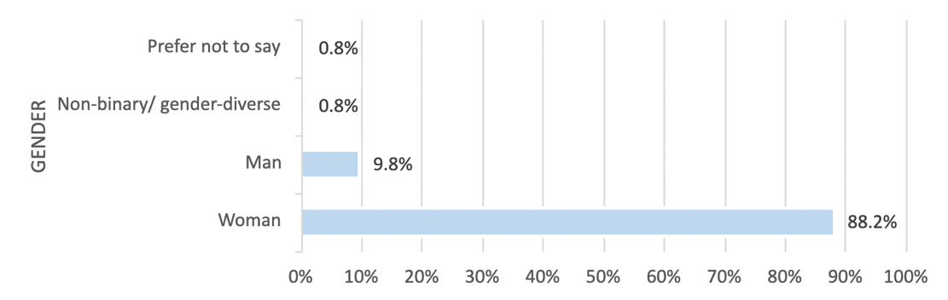

**Fig.1**: Demographic breakdown of survey respondents by gender identity

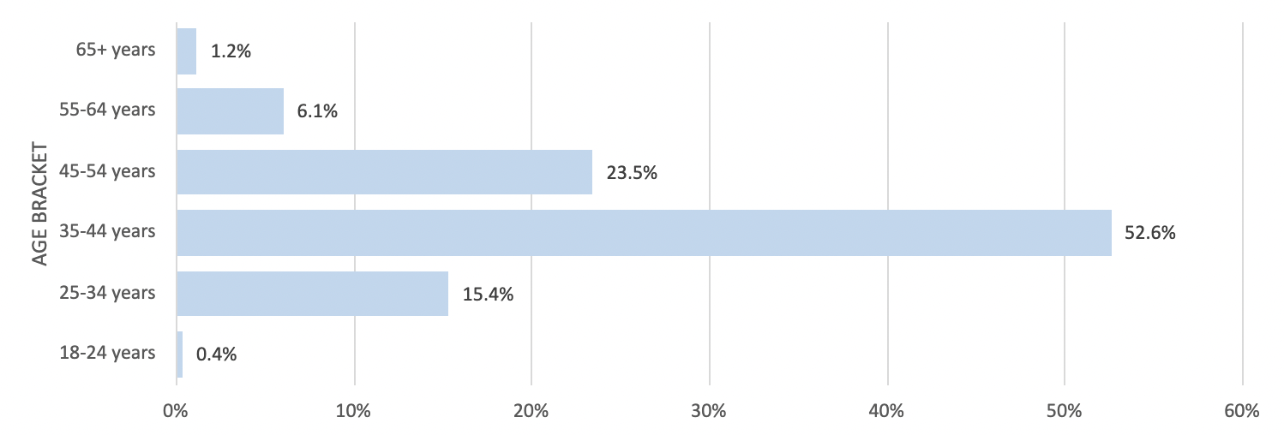

**Fig.2:** Demographic breakdown of survey respondents by age

|  |  |
| --- | --- |
| **CULTURAL BACKGROUND** | **PERCENTAGE** |
| Aboriginal and/or Torres Strait Islander | 2.6% |
| African (including Central, West, Southern and East African) | 0.3% |
| Australian | 54.1% |
| English, Irish, Scottish and/or Welsh | 14.9% |
| Central and/or South American | 1.9% |
| Central Asian | 0.3% |
| East and/or South-East Asian | 6.2% |
| European (including Western, Eastern and South-Eastern) | 12.0% |
| Middle Eastern and/or North African | 0.7% |
| New Zealander | 2.9% |
| North American | 0.7% |
| Pacific Islander | 0.3% |
| South Asian | 0.7% |

**Fig.3:** Demographic breakdown of survey respondents by cultural background

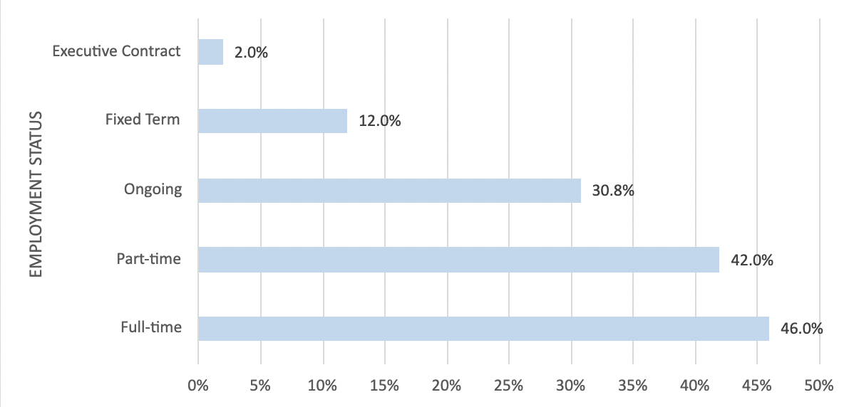

**Fig.4:** Demographic breakdown of survey respondents by employment status.   
(Note: participants were allowed to select all options that applied)

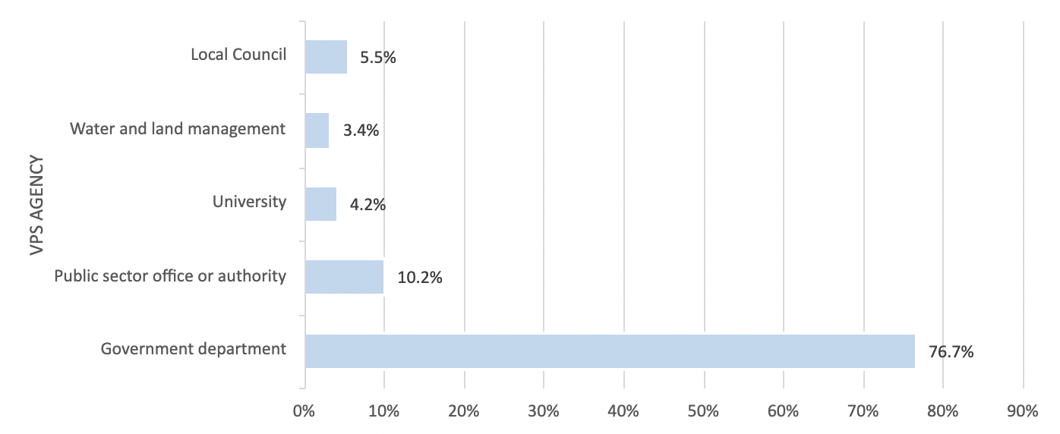

**Fig.5:** Demographic breakdown of survey respondents by top 5 VPS agencies

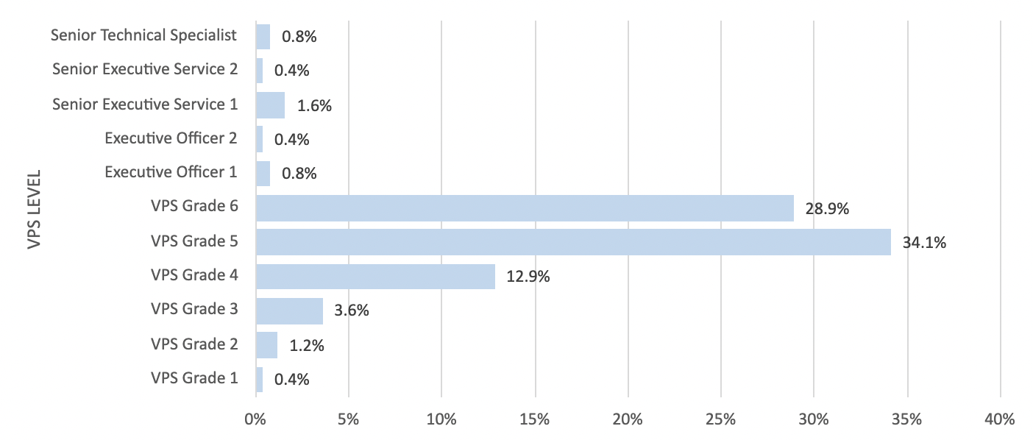

**Fig.6**: Demographic breakdown of survey respondents by VPS level

The sample is over-represented by those who are White, highly educated, middle to mature aged women in heterosexual relationships. One of the limitations of the survey is that despite the higher prevalence of care amongst communities that have been historically disenfranchised and marginalised (e.g. First Nations People, People of Colour, queer identifying, religious minorities, youth, and those with disabilities) these groups are under-represented in the survey. As such, this report stresses that further research is required in these areas to appropriately represent, analyse, understand, and address the intersections of these identities and care responsibilities to effect sustainable change.

## 3.3 Interviews

Between November 2022 and February 2023, 74 semi-structured interviews were conducted to gather additional and in-depth qualitative data, building on the findings of the survey. Interview respondents were employed at 23 different Public Sector Agencies, including 1 public health unit, 6 departments, 6 city councils, 2 commissions, 1 university, and 7 organisations. Interview respondents were assigned a participant ID number to preserve their anonymity throughout the process. Interviews were conducted online using Zoom to accommodate those working from home or located regionally/rurally, and lasted between 25 minutes and 60 minutes, with the average being 40-50 minutes.

The interview consisted of 25 questions, with 35 follow up questions or prompts. Questions throughout the interview focused on topics such as experiences of taking leave and returning to work, challenges balancing work and care responsibilities, and the impact that caregiving has had on career progression.

Audio recordings were transcribed using Otter.ai, then checked manually. Data was then thematically coded using the software platform Dedoose.

When interviews are discussed in the sections below, the quotes included refer to individual experiences and are not generalisations made about the entire VPS.

## 3.4 Audit data

Under the *Gender Equality Act 2020* (Vic), the Commission requires defined entities to undertake a workplace gender audit as part of the Gender Equality Action Plan every four years. Defined entities are also expected to complete an audit every two years as part of progress reporting. Selected data points from the workplace gender audit are published by the Commission on its Insights Portal.

The workplace gender audit is comprised of two different types of data: workforce data, which is drawn from organisations’ internal systems, such as payroll and human resources systems; and employee experience data, which is collected via anonymous survey. Data from both sources are aligned to the seven workplace gender equality indicators under the Act and support defined entities to understand the state and nature of gender inequality in their organisations.

The first workplace gender audit took place in 2021. Through its reporting platform, the Commission collected 67 million data points in this inaugural audit, which represents the most comprehensive gender-disaggregated dataset on public sector organisations in Australia. However, the inaugural workplace gender audit revealed several areas of limited data availability and poor data quality (particularly in relation to data about people who experience intersecting forms of disadvantage and discrimination).

While the Act encourages organisations to collect and submit data that is disaggregated not only by gender, but by other attributes including Indigenous status, race, ability and sexual orientation, it is not a requirement. Data that speaks to the opportunities and challenges faced by employees experiencing intersecting forms of disadvantage in public sector workplaces remains scant. The Commission is working to improve its data collection and analysis, as well as to better support defined entities to improve theirs when it comes to this sensitive data.

Wherever possible, the Commission provided relevant sections of the data to the research teams funded in its 2022 grants round. Research teams received a combination of workforce and employee experience data, but were able to independently decide what data points they incorporated into their research and how they did so. In this project, we received workforce audit data on parental leave taking (referred to below as CGEPS workforce audit data; and VPSC People Matters Survey (PMS) audit data on caring and flexible work. These data are cited below as relevant.

# FINDINGS AND DISCUSSION

## 4.1 Caring Responsibilities

Survey respondents cared, on average, for 1.8 dependants. Just under half of respondents provided care to family members daily, whilst a further 8% provided care or help to friends, neighbours or community members.

Respondents spent on average 63 hours per week caring for their dependants. This is higher than a comparable ABS (2021) survey which found that “Females who participated in unpaid work activities spent on average 4 hours 31 minutes a day, while males spent 3 hours 12 minutes”. This equates to 31.5 hours a week for females and 22.4 hours for males.

The most common form of care was provided to children of school age, up to 18 (47.22%), followed closely by children below school age (42.28%).

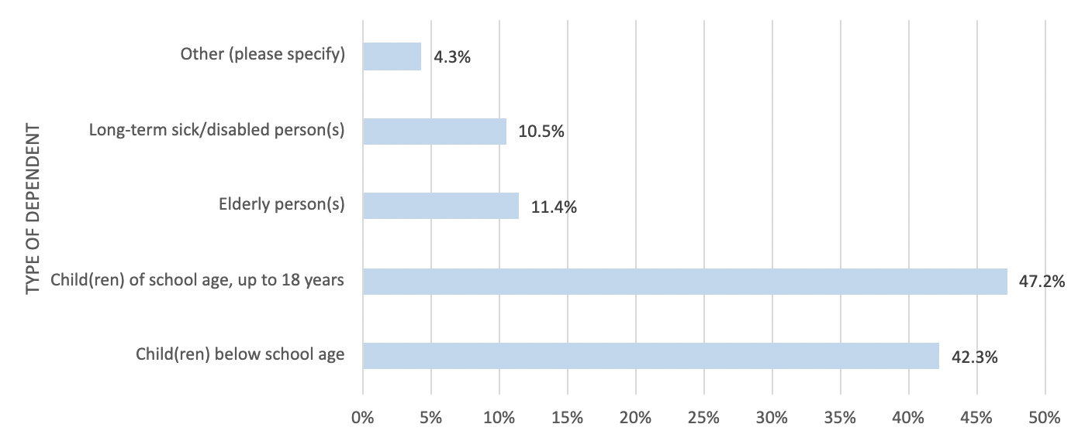

**Fig.7:** Demographic breakdown of survey respondents' type(s) of dependents

## 4.2 Conflicts between Work and Care

67% of survey respondents believed that work has affected their ability to take on a caregiving role. Many respondents had to look for alternative care arrangements as a result of their work commitments.

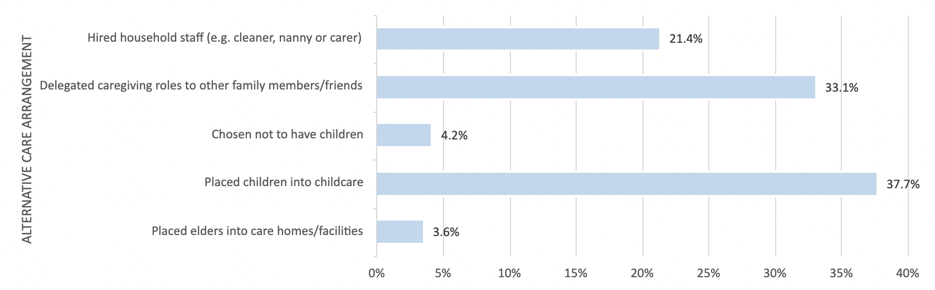

**Fig.8:** Alternative care arrangements utilised by survey respondents

A significant minority of survey respondents experienced conflicts between work and care:

* 26% agreed that it was difficult to respond in an emergency.
* 20% agreed that their job keeps them from sufficiently checking in on the person they care for.
* 22% agreed that the demands on their time are too high for them to keep up their caregiving role.
* 18% agreed that there isn’t enough support for carers provided by their employer.

## 4.3 Flexible Working Arrangements

The workplace flexibility offered by the VPS has made it an employer-of-choice throughout the state. Many respondents admitted to joining the VPS due to their workplace policies, that are renowned for accommodating caregivers.

“You know, one of the main reasons that I am in the public sector as opposed to the private sector is to be able to have that work life balance - is to be able to pick and choose a little bit of when I'm taking more time for family.” **(P63 - Man, 41)**

“So knowing that they had kind of a flexible work arrangement is one of the reasons why I sought out applying for the role there. Otherwise, I probably would never have applied. Yeah, to have that flexibility to do the work from home and not have to commute.” **(P32 – Woman, 44)**

The VPS offers a diverse range of flexible working arrangements to employees, including flexible start and end times, a compressed work week, hybrid working, remote working, job-sharing, and a 4-day work week. Respondents highly valued these arrangements:

“Having this, where I am now, being able to flex and hybrid and compress my fortnight has been life changing for me. I would not be working full time now [without it].” **(P20 – Woman, 50)**

That said, the use of flexible working arrangements can be gendered. According to the **PMS**, 23% of women compared to 16% of men have requested flexible working arrangements. Women are more likely than men to request workplace adjustments for caring responsibilities (8.1% of women vs 4.9% of men) and family responsibilities (9.6% of women vs 6.2% of men). Non-binary respondents answered similarly to women on requesting flexible working arrangements, with 23% having requested flexible working arrangements, and were between men and women in the proportion requesting adjustments for caring responsibilities (7.7%) and family responsibilities (7.1%).

**CGEPS workforce** audit data indicates that by industry, flexible working arrangements are utilised most by women in the Victorian public service sector (86%) and men in the transport sector (57%). Comparatively, flexible working arrangements are used the least by women in the transport sector (43%) and men in the Victorian public service sector (14%). This was similarly reflected in workforce audit data that measured the prevalence of formal flexible work arrangements by industry, with the Victorian public service ranking highest (35%) and transport ranking third-lowest (10%).

The most utilised flexible working arrangements amongst interviewees in this study included flexible start and end times (70.27%) and hybrid working (85.14%). These findings were similarly reflected among survey respondents (see Figure 9).

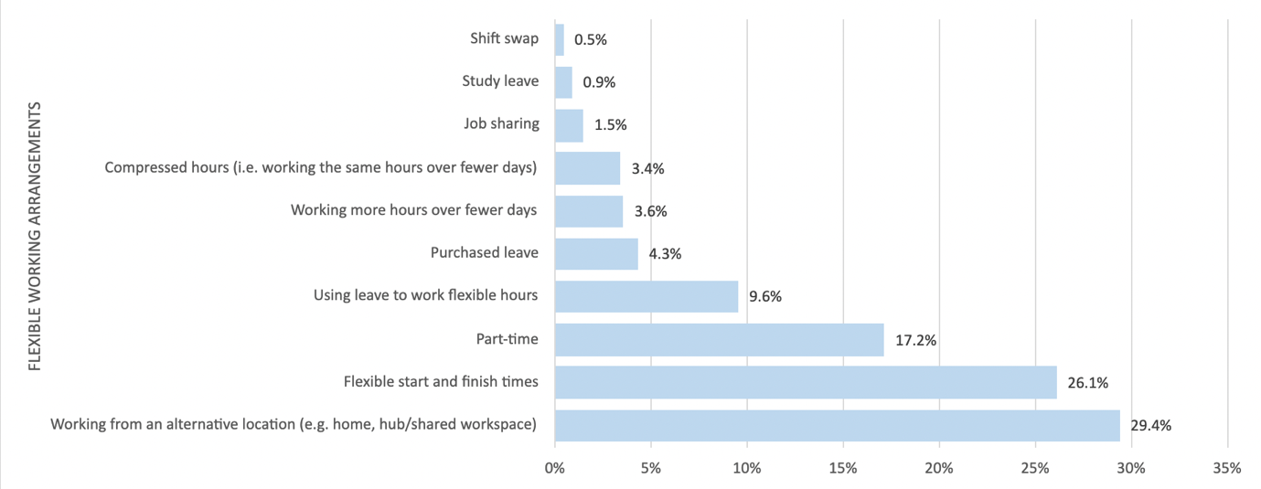

**Fig.9:** Types of flexible working arrangements utilised by survey respondents

Interview respondents recounted how greater flexibility made them more productive, more engaged and less burnt out at work. This is similarly reflected in research conducted by Ruppanner and colleagues (2023) who found that caregivers tend to be harder working than non-caregivers. They found that 40 percent of working caregivers believed they were more productive now than they were before the pandemic. Ray & Pana-Cryan (2021) also found that work flexibility in terms of location and hours gives workers a sense of control, whilst improving their engagement and productivity, and increases job satisfaction. They were also more likely to note a lower turnover rate when flexible accommodations were made.

“Working flexibly has made it possible for me to be much more productive. And I think that's great. And I think it's an advantage to the workplace, but also to me personally.” **(P64 – Woman, 52)**

Many respondents spoke about how hybrid working and working from home assisted with their caregiving responsibilities. While some found that they had more time to provide care to their dependants due to eliminating commute times, others noted how working from home afforded them pockets of time to attend to menial household tasks that would otherwise compound due to more pressing caregiving or work responsibilities:

“I can't imagine how I would work otherwise. I don't know how people juggle caring responsibilities... working from home just makes it possible. Because I mean, I live on the Mornington Peninsula. ... I couldn't possibly have worked in the CBD two and a half, three days a week and lived on the Peninsula. ... I just don't know how I would have done it if I couldn't work from home that day and a half. Plus, as I said, I can put things like the washing on and put the dishwasher on and all those sorts of things while I'm home working.” **(P56 – Woman, 39)**

Conversely, respondents noted the extreme difficulties they experienced when flexibility was not possible, potentially forcing them to leave their role:

“the current role I've moved to has very limited flexibility, which I found out since starting, not during recruitment, and very high expectations for extended overtime and seven day a week availability, which they also didn't tell me during the recruitment process. So I can't actually do it. And I'm in a terrible situation, where am I going to have to leave or potentially be doing all this overtime that I can't really service. So I'm looking for another job, basically. So no, there's no flexibility in this job.” **(P45 – Woman, 42)**

While flexibility has been an option available to VPS employees to varying degrees in the past, the onset of the COVID-19 pandemic cemented these practices as a preferable way of working that can be made more readily available. Interview respondents expressed concern, confusion and anxiety around whether flexible working arrangements would continue in a post-lockdown setting, as there has been ongoing pressure to ‘return to normal’ ways of working.

“how long will this flexibility in working from home post COVID, insofar as we are post COVID, how long will that stay? Like is this a permanent arrangement? And can we start to make other decisions based on will we work from the office, you know, one day a week, for example?” **(P37 – Woman, 50)**

“I think some people, particularly our most senior executives, feel uncomfortable when people aren't in the office very much. They would like to see people in the office, because they have some held beliefs around productivity and presence.” **(P30 – Woman, 54)**

Interview respondents advocated for flexible working arrangements to be maintained as standard practice throughout the VPS, rather than an exception made in strenuous circumstances. This would require commitment, assurance and acknowledgement that flexibility is key to better ways of working in the future, including to achieve gender equality for caregivers.

“I think better ways of working isn't just good for parents, I think it's good for everyone to be working differently. I think workplaces that are flexible and support, are better for everyone.” **(P42 – Woman, 36)**

At present, the availability of flexible working arrangements hinges on the relationship of each employee with their individual manager. Workers are expected to request flexible work arrangements, and to negotiate how they will work in practice with their manager. And yet, in this study, when survey respondents were asked, “if you needed to provide help to a dependent during the workday, how comfortable would you feel discussing this with your immediate supervisor?”, 39% of survey respondents said they would be ‘extremely uncomfortable’. These circumstances are not uncommon, with the work of Williamson et al. (2020) stressing that progressing gender equality at a management level is often impeded by a lack of line manager Human Resource Management (HRM) expertise and institutional forces hampering change initiatives.

Respondents felt there was still a resistance to some forms of flexible working in some part of the VPS; and flexible work arrangements could be refused due to these assumptions:

“They are still more of the mindset of be seen to be seen. So you know, we're encouraged to be in three days in the office and two days from home. That's the balance maximum at the moment. I think that reflects the change resistance of organisations like the public sector.” **(P63 - Man, 41)**

“I think that one of the things that we lack... is a more explicit kind of interpretation, but also process for making decisions around work and caring. So there's a tendency to be like, oh I'm a bit worried about that, I'm not going to approve that because I don't think I can really trust them to work from home. Versus oh, that person is really awesome, I will approve that because I really trust them to deliver in that.” **(P30 – Woman, 54)**

Respondents felt, for example, that there was scope to enable more job-sharing opportunities throughout the VPS. This was particularly prevalent among working mothers and caregivers that re-entered the VPS following a career break. Both demographics stressed the importance of and value in being able to work part time to achieve a better work-life balance. This working arrangement ensures that employees are able to work under less pressure and provide support to one another. As Mohn (2021) identified, job sharing is of benefit to both the employee and employer, as it reduces absenteeism, increases productivity, and retains high-quality employees that otherwise wouldn’t be able to work without flexibility. This ultimately creates a culture that fosters healthy boundaries and provides support systems to caregivers.

“And it's like they have this sort of blinkered view and they don't consider things like job share. And when I first came back to my position I wanted to be part time. And I started off being two days a week and then went to three days a week in a job share position. And my colleague and I, we worked really well. And it was fantastic for us, because she would spur me on. She'd been there for two days, she'd send me this long handover with all the things she's done. And it almost made me competitive like, well, this is what I've done in three days. And you know, it really egged you on to work well, and we worked so well together” **(P70 – Woman, 52)**

“... the kinds of conversations we were having at a departmental level about how to encourage more women in the executive, around job sharing arrangements, which again, I think speaks to the fact that no single person can do the job and also have a caring responsibility.” **(P13 – Woman, 41)**

While most respondents had been provided with the flexibility they requested, several respondents disclosed experiences of discrimination and the denial of flexible working arrangements. The availability of flexible work is highly dependent on the level of understanding and empathy managers have towards their employees with caregiving responsibilities. This is what Chung (2020) defines as “flexibility stigma”, which is the perception that workers who use flexible working arrangements for care purposes are seen as less productive and less committed to the workplace. This stigma can be particularly prevalent among managers and co-workers.

“you have to prove so many things to get any kind of flexibility. You have to beg ... there's so much of that resistance and pushback at the manager level.” **(P15 – Woman, 40)**

While some managers were unsympathetic or unaccommodating to requests for flexibility, senior figures within the VPS were denied flexibility as well. High-level VPS employees reported that the most common reason why they were denied flexibility was due to staff member management requirements for those below them. Flexibility needs to be available at all levels of the VPS to encourage a sustainable and more empathetic workforce, and to enable promotion and progression for those with caring responsibilities.

“the more senior you are, I think the harder it is to achieve flexibility. ... I've heard of there being senior leaders who do work flexible hours, job share. I don't know any of them personally. So I think it's probably quite rare. And I think the more senior you are, the harder it is.” **(P56 – Woman, 39)**

“I just feel like, you know, what I see of how those managers work and the hours that they work. I feel like it's not compatible with parenting young kids at this point.” **(P68 – Woman, 40)**

Similarly, in the survey, 25% of respondents reported that they believed using flexible working arrangements was a barrier to success in their organisation. Additionally, 25% of survey respondents reported that they had considered leaving their current organisation due to a lack of support given their caregiving responsibilities.

## 4.4.1 Taking Leave: Information Gaps

An overwhelming majority of survey respondents – 64% – indicated that they had not been made aware of their rights as caregivers in the workforce. 48% of survey respondents felt that there are not enough resources and information made available for caregivers in the workforce.

Interview respondents similarly felt that leave entitlements, and the systems required to claim time off, are complex and difficult to navigate. Information around the various types of leave offered by the VPS was regarded as inaccessible and challenging to understand without assistance. Interview respondents reported that they often had to turn to HR and payroll services to understand their rights to take leave, as managers did not (or could not) always support them to understand their entitlements.

“Yeah, so I mean, the EBA is very easy to get a hold of and go through. But it's once you start actually delving into the detail of each clause that the difficulties arise and that you need to seek advice, and then you try to get it from HR, but turns out, I don't know. The only person as it turned out in the end that's been able to answer all the questions has been someone in payroll … So there's just been a lot of back and forth, but at least someone eventually at the end of the line has managed to answer it.” **(P12 – Woman, 32)**

“[My manager] was very supportive in terms of me taking the time off and doing whatever I needed. But when I asked her what my entitlements were, she said, I don't know. Maybe just have a look on the internet. And when I did that search, nothing came up. And then I asked HR and they said, no just take sick leave. So I guess no one really knew what it was until I did my own research. And then HR apologised and said, you know, you're right**.” (P59 – Woman, 33)**

“HR is increasingly inaccessible for staff... I remember HR used to be a group of people and you could go and talk to them and you could ring them up and there was always someone there. Now it's like, send us an email, we'll get back to you in three days. It will come back to you from payroll team, like you don't actually have an interaction with the person. It can be quite difficult to get a nuanced and in depth understanding of your rights and responsibilities in that mechanism. HR is now a very transactional function in our public service. And so you're very reliant on your manager, and your manager’s manager. And if you're lucky enough to have someone who's very lenient, that's fantastic. And if you've got someone who's very like this, too bad. It's very difficult to work around that. And to find that, you know, someone who's sitting three seats away from you, and has got a completely different understanding of their entitlements than you do, is really problematic.” **(P30 – Woman, 54)**

Respondents professed confusion as to when they were allowed or not allowed to access their personal or carer’s leave, with limited clarification offered in the EBA or guidelines. This often meant it was up to the discretion of their manager to grant them access to time off.

“Is it different if I stay home because my mum was really sick the day *after* chemo versus taking her to chemo? Are they the same? One is a planned event and therefore you can't use carer’s leave for it, one is an unplanned necessary caring. The way in which the rules are written are ambiguous enough that people can be punished or they can be used punitively, or they can be used permissively, depending upon your management.” **(P30 – Woman, 54)**

Women respondents in particular disclosed that they felt confused when navigating the system to apply for their parental leave entitlements. While policy documents outlining these entitlements are available, their language is complex to understand. Similarly, policy and practices for employees whilst on parental leave are unclear and vary across organisations. This results in employees feeling confused and isolated whilst taking parental leave.

One way that respondents managed this opacity was by assisting each other to navigate complex information and systems:

“Yeah, I found it quite confusing to find out the information that I that I needed to know. I had to book a time with an HR representative. It was also during COVID. And so everything was working from home. And that I guess that adds a layer of difficulty that you can't just go and talk to someone, you have to be writing things down. And there's more room for misinterpretation. So I had to go back to this HR person, maybe two or three times with further questions. The nice thing was that one of my colleagues was also taking maternity leave at the same time. And so we kind of did this together, and we shared all the information.” **(P44 – Woman, 38)**

These informal peer support structures could be formalised by establishing networks for carers across the VPS.

## 4.4.2 Taking Leave: Discrimination, Repercussions and Consequences

Respondents taking parental leave also flagged some of the potential risks of taking leave, particularly for those on insecure contracts, with contracts expiring, or in temporary roles; or where restructures occurred while they were on leave.

“When do I tell my manager that I'm pregnant? At the same time, my contract was ending, and I was like, oh no, do I tell my manager before my contract renews or after? And luckily I had the HR business partner to give me some advice that the policy states that you don't have to let them know until not much out, like two months out or something. So her advice was not to tell my manager until my contract was renewed just in case, even though it shouldn't have any bias, even though it shouldn't have any impact on the decision. It just was safe proofing me and I just feel very comfortable talking to that independent HR advisor.” **(P34 – Woman, 35)**

“But with my first baby while I was on maternity leave with her, I got a letter in the mail from work saying we've spilt all the positions, and you'd have to reapply for your position. And so this is just by a letter. And this was during the time where my baby actually had a disability, we were going through operations, and were severely sleep deprived. And they were telling me that I had to re-interview for my ongoing position. And I freaked out, I thought, there's no way I'm going to get that - there's somebody acting in my role, he's full time. And I want to go back, you know, reduced days because of my caring responsibilities, there's no way they're going to give me the job. And so I didn't even go for it, I didn't go for my own job, because I thought I'm not going to get it.” **(P62 – Woman, 43)**

“So in my substantive position, I'm a manager of a team, I spent years building up a career in this particular organisation and working really closely with the executives across the board. And then in going away, I took 12 months off, which I ended up extending, I came back and it was just, you know, my career was decimated, I basically came back - didn't have a desk, didn't have a pass, discouraged from returning to work the number of days that I wanted to return to work. They had someone acting in my role and they felt uncomfortable removing that person from my position. So I felt obliged to return to work full time, so that I could elbow myself back into the role.” **(P13 – Woman, 41)**

For some respondents, this represented a lack of care for those with parental responsibilities:

“I've noticed a lack of care around women when they do go on maternity leave, like managing their careers, like there's no plan. There's meant to be plans and they're meant to do these in touch days, and yada, yada, yada. But like that stuff never happens. And it's like, unless you have an executive that likes you and has your best interests at heart, you will end up in a bad position in your career. You will be disadvantaged when you return to work, and I've seen that happen to so many women in my organisation... when it comes to supporting the careers of women and having their best interests at heart, when they're on parental leave, there's none of that.” **(P25 – Woman, 34)**

Upon their return to work post parental leave, a significant number of respondents shared that their transition back into the workforce was tumultuous and unsupported. They faced particular challenges with management, who were often dismissive and undermining of their role in the team following a career break. Mothers were more likely to report feeling this way, as they often returned to work on a part-time basis and were assumed to have lower capacity and skill than men due to their caregiving responsibilities. This is reflected in research conducted by Weisshaar (2018) who found that mothers faced penalties in hiring and wages relative to fathers and childless women, due to their time spent out of the labour market because of caregiving responsibilities.

“One of the things that I've been talking about is that we don't support not just women, obviously, but primary carers having children when we return to work in the same way that we support people who have an injury, or an illness. They have a return-to-work plan, and they sit down in theory, if it's working or properly sitting down with a return-to-work plan about how things are going to work and regular check ins. We don't do that for women, and primary carers returning to work.” **(P13 – Woman, 41)**

“When I became pregnant, almost immediately, there was a managerial attitude change towards me as a resource, which came from the fact that I struggled into the office at nine o'clock feeling like death, you know, that kind of thing. While I was on maternity leave, my position was moved within the organisation. So I reported to someone different. When I returned, most of the other executives that I'd had working relationships with had left because there had been a senior leadership turnover. I came back and I worked for someone else. And I am not exaggerating to say I was not given any work to do. So I was paid an executive salary, to sit at a desk and do nothing. And I kept trying to meet with my boss to talk about how deeply unsatisfying this was. And she dodged meetings with me for nine months after I returned from maternity leave, and I was working three or four days a week at that stage. When I finally managed to have a meeting with her, she said, you're not valuable to me until you can work full time. And at your age you have about a year before you can expect that your career will be over if you're not working full time. And so I resigned.” **(P30 - Woman, 54)**

These responses illustrate that the VPS needs to develop better supports for those returning to work after a period of leave. This applies to all types of caregiving leave, not just parental leave. Further support systems are necessary to facilitate transitions in and out of taking leave. Similarly, there needs to be greater recognition of employees’ value despite (or even because of) their caregiver status, roles and responsibilities. Time out of the workforce, or part-time work, does not equate to a deterioration of skills or career disinterest. Research conducted by Fuegen et al. (2004) found that while perceptions of caregivers in the workplace, particularly mothers and fathers, are often driven by gender stereotypes, their competence should not be conflated with their caregiver status.

## 4.4.3 Taking Leave: Inadequate Entitlements

In the survey, 31% of respondents agreed that there is insufficient paid leave to keep up with their caregiving roles. For interview respondents, this resulted in caregivers resorting to using their annual leave entitlements or taking unpaid leave to meet their care responsibilities:

“So if your leave’s gone, your leave’s gone, then you're looking at unpaid leave. Not only do you not get paid, you also don't accrue any like long service leave or annual leave on those days. So it impacts you down the track as well.” **(P9 – Woman, 38)**

Respondents highlighted how they often used personal leave after their carers leave ran out when their dependants were sick, which left them with little to no sick leave to look after themselves. This was particularly prevalent among mothers with children of pre-school to primary school age. As a result, caregivers reported higher rates of exhaustion and burnout as they had to sacrifice self-care to prioritise their dependants’ wellbeing and work responsibilities whilst sick.

“I do notice that while others get to build up their sick leave/ carer’s leave, that doesn't happen much for me. It tends to get used, and sometimes that means there's not much left, because I've used it for her. Yes, I think there’s still some inequity in all of that.” **(P73 – Woman, 56)**

“A lot of the females in our organization have lower personal leave balances than their male colleagues because they often take on board a lot more of the caring responsibilities. So, I think in order to support that, it would be wonderful if there was more personal and caring leave arrangements.” **(P3 – Woman, 32)**

This was influenced, too, by a lack of flexibility, and requirements to be physically in the office, which limited respondents’ ability to manage minor illnesses:

“I think we're being forced to work in the office and not having any flexibility to work from home, that things like your kid having sniffles or you having a cold or whatever means you can't come into work. It means that you can't do your job. So I wind up taking unpaid leave, just because my kid was in childcare. And she's only one and a half, you know, so just constantly sick. She's a toddler. And then I'm constantly sick. So I think that was really hard saying can I work other days instead? Can I make up the time? Or can I swap workdays and work other days, and that was all declined. So it's unpaid. Because it's out of carers leave.” **(P67 – Woman, 32)**

Caregivers who work part-time receive a pro-rata amount of paid personal/carer’s leave based on how many hours they work. However, as several respondents noted, it does not reflect the persistent needs of caregiving. Respondents also reported that some managers did not understand ‘how to pro-rata' leave entitlements, leaving employees with inaccurate and disproportionate allotments of leave.

“if your manager is crap, or your manager doesn't know how to pro rata, and they haven't been provided enough support in actually understanding what that flexibility looks like, tangibly, and what actions they have to take for that employee. So that's the gap.” **(P45 – Woman, 42)**

## 4.4.4 Taking Leave: Gender Disparities

Respondents reported that men take significantly less parental leave and are less likely to make use of flexible work entitlements than women, due to social norms and gendered expectations and the gender pay gap perpetuated by managers, leaders, and senior employees. This is consistent with **CGEPS** **workforce audit data**, which indicates that 2.8% of men took parental leave in the 2020-2021 financial year compared to 5.8% of women, with men who took parental leave taking an average of 5.1 weeks paid and 2.9 weeks unpaid compared to women who took an average of 25.4 weeks paid and 21.0 weeks unpaid parental leave. Ewald, Gilbert & Huppatz (2020) highlight how social, organisational, and gendered norms shape men’s decisions around leave taking and flexible working arrangements. They note how this is particularly prevalent amongst fathers.

Interview respondents recounted that men in the VPS are often not encouraged or do not feel empowered to take more than the statutory parental leave allowance (at the time of this study, 2 weeks). There is still a gendered expectation that men will not utilise parental leave to the same extent as women or primary caregivers. Fleishcmann & Sieverding (2015) found that because men taking parental leave still runs counter to gender stereotypes, it often results in backlash. They go on to explain that typical backlash for men in a work setting includes being less respected and seen as less competent. Respondents commented on how men often have to make a stronger case for extending their parental leave entitlements, as they faced bias and criticism from managers and older co-workers about going against ideal worker norms that see men as more work focused and not family orientated. These sentiments are strongly reflected in studies investigating the experiences of caregiving fathers (Kelland 2022; Kelland et al. 2022).

“I think there's still an expectation that if you're a male, you will just take your two weeks paternity leave and then go back to work. Whereas if you're a female, then you're expected to be given those part time hours. So I don't know any men that have worked part time due to caring responsibilities, and I know a lot of people. So you know, I'd like to see more men going part time.” **(P62 – Woman, 43)**

“[I] haven't encountered many men who have taken it [parental leave]. And so yeah, there wasn't the ability to really talk to other people, other men about their, their experiences.” **(P60 – Man, 36)**

There is a need, then, to extend the cultural supports for caregiving to include men.

“there's a really positive culture around women taking extended leave and coming back to, transitioning back to part time when they return. ... I don't feel that that culture has emerged yet for men. So I think there's probably some work in that area that could be done to encourage and support men to take up the policies. Again, encouraging men to do it. Yeah, just like shifting that so it becomes more of a norm that men do it like everyone else does it.” **(P60 – Man, 36)**

This cultural shift could be encouraged by promoting examples of men taking leave to care, and through role modelling by senior men in the VPS.

“It is very rare that the men in the teams that I have worked in, or teams that I work closely with, are not there because they're caring for their children. It's not something that you really hear about ... It's certainly not something that's promoted within the organisation. It's not *not* promoted, but it's just that no one talks about it, and therefore that culture just is perpetuated.” **(P18 – Woman, 34)**

## 4.4.5 Taking Leave: Non-normative Circumstances

For respondents, some reasons for leave taking were not met with the same empathy and support as others. In particular, respondents shared that instances of family violence and miscarriage were often handled inappropriately and without compassion. Caregivers who had experienced these forms of hardship were often not aware of leave entitlements that existed for those exact reasons.

“to access family violence leave ... you had to fill out the form like a memo or submit the memo or to request and justify why you needed that leave. I refuse to do it. Because I didn't want the written record, because just talking to someone, this caused much pain to me. I didn't want the written record anywhere about me going through what I was going through, because I don't trust who was going get this piece of paper. I don't trust. I don't know if that's still the process. I hope it's not anymore.” **(P47 – Woman, 49)**

“They were both relatively early on. So I hadn't even got to the point of providing the certificate proving that I was pregnant or anything. … particularly for the second miscarriage, I had to have a procedure and everything. And when I asked my HR about what my leave entitlements were they said just take sick leave, which was so distressing. Because ... I wasn't sick, I'd lost the baby. ... I did my own research and realised that we are entitled to three days compassionate leave for that. So yeah, I think it was her lack of knowledge about what the entitlements were that sort of contributed to that.” **(P59 – Woman, 33)**

Further, forms of caregiving outside the nuclear, heteronormative family were also more likely to face criticism and a lack of empathy. This included, for example, practices of community care, men as primary caregivers (discussed above), and intergenerational caregiving. Respondents providing care to a dependent who was not their child or parent reported receiving significantly less support and understanding than would be afforded to parents.

“I don't think that the kind of grandparenting thing is commonly understood. And so my colleagues have young children, but it's a very different headspace. I think saying that your grandchild is sick is not the same as saying your child is sick, in terms of how people might respond.” **(P17 – Woman, 56)**

“If they're caring for a person with a disability or mental health issue or, you know, an injury or elder, that kind of thing, there seems to be a greater likelihood of them feeling less confident about being supported. So yeah, I guess you could call them minority carers, really.” **(P65 – Woman, 50)**

## 4.4.6 Taking Leave: Fear in asking for entitlements

For some respondents, asking for leave or flexible arrangements was seen as too risky in their particular workplace circumstances.

“I'm too nervous to ask for it [my entitlements]. Because I think that with the job that I have, I don't think it would be looked kindly upon.” **(P23 – Woman, 48)**

Respondents on short and fixed term contracts were more likely to report feeling a heightened sense of insecurity when trying to access their leave entitlements, reflecting studies that show a strong causal link between job insecurity and limited contracts (Hur 2022; Pavlopoulos & Chkalova, 2022). While respondents were aware that they were entitled to leave, many disclosed that they felt significantly less supported throughout such processes due to their employment type.

“the other thing in the VPS is that there's a lot of short term or fixed term contracts. And so, you know, if you're looking at going on parental leave, at a certain time, and your contract expires, I don't know what happens to parental leave, or whether you get part of it, or that kind of thing. So something I really appreciate with my current contract is that it's ongoing.” **(P31 – Woman, 31)**

Job insecurity meant respondents were less likely to ask for accommodations or flexibility, for fear of losing their job altogether:

“There is zero job security on contracts for people in my position. And it's, in my opinion, one of the biggest problems with the current public service and for women particularly in the public service, getting that equality and that empowerment to negotiate conditions that work for us because basically if you're too much of a pain, they're just gonna go alright, your contract’s finished. Thanks. Here's a handshake. See you later. Yeah, that's how I feel like it affects my confidence and my ability to want to talk about issues with my manager.” **(P45 – Woman, 42)**

## 4.5 Career Progression

A majority of survey respondents – 61% – agreed or strongly agreed that their caring responsibilities had negatively impacted their career advancement. In the survey, as a result of caregiving responsibilities:

* 46% of respondents had worked in a job lower than their skillset
* 38% of respondents reported lacking the knowledge and confidence to apply for jobs and promotions
* 22% had turned down a new job or promotion
* 19% had been denied an opportunity
* 10% had quit working or looking for work

Interview respondents on secondments, or in part-time and contract roles due to their caregiving responsibilities, reported that they were less likely to be recognised as valuable employees, and less likely to be offered opportunities at work. Respondents commented that due to their lower work hours, they become less visible in the workforce. As a result, they were assumed to be less committed and productive. These challenges are reflected in studies conducted by De Smet et al. (2021) at McKinsey and Nielsen & Yarker (2022).

“Even if you only take six months maternity leave, you're still probably talking about a year out because of pregnancy as well. So I think that you're then out of people's minds in terms of thinking about opportunities for growth and promotion. And you're always at a disadvantage if you're seeking acting up opportunities because they've got to then consider you as not full time, you know, unless it's conveniently a part time role” **(P35 – Woman, 43)**

**“**Yeah, those things can maybe limit your aspirations, or maybe people just assume that you don't want to take on more responsibilities if you've already got very obvious caring responsibilities, that you won't want to take on extra responsibilities at work. So maybe sometimes people think they're trying to be kind and supportive, but actually they're limiting your options.” **(P35 – Woman, 43)**

Those on secondment often highlighted how, in an attempt to gain skills and experience in another area of the VPS, their career stagnated as they were unable to apply for promotions or leadership roles whilst in a temporary team, or to access relevant training.

“And she said, well you know I wouldn't let you do that training because you're not an ongoing staff member with us.” **(P70 – Woman, 52)**

Discrimination on the basis of caregiving was the foremost reason why many respondents felt that they were denied or actively passed over for opportunities to progress in the VPS. Applications for promotion and/or leadership opportunities were rejected; in many cases, respondents were told directly that it was due to their caregiver or impending caregiver status. These experiences are reflected in several academic studies on the inclusivity of caregivers in the workforce – namely, Schofield (2022) and Hernando (2022).

“I think it's something my boss has said to me... he jokes about it. But it'd be something like, you know, you've got to stop having kids so that you can have an opportunity to sort of step up into his role.” **(P19 – Woman, 35)**

"I applied for a contract and that role just started two weeks ago. But they said that ... they had selected me, but they weren't going to offer me the job because I was pregnant. Which I hadn't told them. So yeah, it's been really difficult trying to be positive and excited and planning for parental leave. Given all of that stuff.” **(P67 – Woman, 32)**

“I've definitely not got a job because of it... they said, oh it's because you have school aged kids and we don't think you'll make yourself available. So that was their feedback. Anyway, so I've definitely not got jobs and it's affected my career progression. 100%.” **(P45 - Woman, 42)**

Some respondents reported particular challenges with female managers, who had had to juggle work and care under difficult circumstances, feeling other women should be held to the same standard. This is not an uncommon trend, with similar experiences highlighted to be particularly prevalent amongst younger women in the workforce, in studies by Ahiante & Ndaguba (2022) and Rouvroye et al. (2022).

“Most of the men managers I've had have been fantastic... I just want to highlight that a lot of them have been so supportive, they've gone above and beyond, it's a sit down, it's a civil conversation. It's a lot of the women I found that have been the most horrible, the “I did this, I did that”. And some conversations - “I didn't work when my kids were that young”… And that's probably the hardest part. It's the women, because the women are comparing you to what they did. Yeah, but a lot of the men are just like, “Yeah that's fine. Something's happened to the kids yep, let us know tomorrow. We'll work around it. It'll be fine”. No stress, even though they're stressed. They just take it on board. But the women, nup it's quite brutal.” **(P10 – Woman, 36)**

Respondents who had been denied opportunities for growth in their role reported high rates of burnout. They expressed exhaustion, frustration, and stress while trying to balance their care and work responsibilities with the bureaucratic processes and challenges that come with advocating for career advancement. This experience was most common in women caregivers. A significant number of women respondents disclosed feelings of guilt, both in the workplace and at home.

“You're always constantly feeling like you're failing, you know, you're bad, you're a bad parent, or you're a bad employee.” **(P3 – Woman, 32)**

Respondents with intense caregiving roles – for young dependents, those with a disability and mental illness – were less likely to pursue leadership opportunities or career advancement due to the pressing and chronic demands of their caregiving responsibilities.

“I'm happy to settle, which is entirely unusual, because before that about every three and a half to five years I used to change my work, and that was because I was always solving problems and doing projects … and I'd go on to the next challenge. So my preference would be to find a new challenge for sure. But given what I've decided in terms of the care and attention that I would like to pay to my son and his schooling and his wellbeing, yeah, I can see at least the next three years, if I'm still in this role being quite, absolutely plateaued. So that would add to the total plateau. Probably could even be 10 years of plateauing. So could I do a different role and still attend to him in that way? I don't think I could do it, I don't think it would be worth it for my mental health.” **(P36 – Woman, 54)**

A potential lack of career progression – for women caregivers in particular – meant respondents were often hesitant to have children or delayed having children. Despite its prevalence as a commonality between women in the workforce over the last few decades, numerous studies highlight how this topic remains taboo and limits success in their careers (Lazzari 2022; Skirbekk 2022).

“I think that once I have a family, I won't be able to progress in my career. ... the perceived challenges that having a family will have [on] the ability to succeed in the workplace.” **(P3 – Woman, 32)**

“I definitely dragged my heels on having kids ... you've got to get some runs on the board with the job. You can't just start a job and get pregnant, or you'll get stuck in a low-level position forever. So yeah, I dragged my feet for ages.” (**P48 – Woman, 35)**

Women caregivers faced a similar challenge later into their careers when deciding to expand their families. Extended maternity leave and/or periods of maternity leave taken closely together were often seen as detrimental to career progression, due to a lack of visibility and perceived skill-deterioration.

In extreme circumstances, respondents actively hid information regarding their caregiver status from employers and their immediate teams. This included lying about the age of children, removing wedding rings during interviews, and hiding pregnancy for extended periods of time.

“Once I had kids, I would gloss over. I wouldn't tell the truth. I just would be vague about how old they were. Like the first time I interviewed for the new role from maternity leave. At the time, my son was four months old. So I just said he was preschool age. He was an infant, yeah. Because I didn't want to, you know, otherwise, they'd be like oh my God you've got a *baby*-baby. But I always planned to go back to work when he was about six months old. So like, it's the right time for me, but I thought most people take off a year. And they'd be like, whoa no. But if a guy interviewed and had a four-month-old, no one's gonna give two hoots. So I just sort of said preschool age.” **(P48 – Woman, 35)**

“So at the beginning, I actually didn't tell them that I was pregnant because I was so new in the role. And I hadn't yet become permanent in my role either. I started off in a contract role and then moved into the permanent position. So at that stage, I was pregnant but I was hesitant to raise it. So because I was on a contract, when I needed to take appointments, I just wouldn't tell them why, I would just say I need to take this day or maybe I would say for an appointment. But you know, they just thought it was for other medical reasons. And then I just wouldn't get paid that day.” (**P12 – Woman, 32)**

“When I was younger... whenever I did an interview for a new job, I never wore my wedding ring. Because I was worried that they’d assume that I would join and go and have kids. So therefore they would choose someone else. But once you had kids, I was like, well, that game's up.” **(P48 – Woman, 35)**

Careers stagnated again when respondents took on care for their parents, partners and family/ community members. For some respondents, this exacerbated their economic precarity and financial insecurity, limiting their superannuation in particular. Shaw denotes this conundrum as “a persisting chasm” that especially derails working mothers’ long-term financial security (2022). In several cases, respondents resorted to finding alternative care arrangements rather than taking on this responsibility themselves. Respondents felt there was better understanding of caring for children, than for caring for other family or community members.

“Yeah, there's probably a better acceptance for children. Or somebody who's elderly and unwell than for somebody like my husband. He's a bit of an anomaly in this. Traditional carer's role is either for, you know, an elderly parent, or a sick person, or small children. They don't consider a 54-year-old male who looks perfectly well to be in that box. So I find it just exhausting to retell the story of why he's not well, and a lot of the time, I think it's absolutely nobody's business. And that frustrates me that I have to keep telling the story in some ways to justify doing what I do. And there's not, although it is on paper, there's still not a greater acceptance of mental health and how it can really cripple you from doing anything, or functioning normally just as other people would function.” **(P61 – Woman, 48)**

## 4.6 Workplace Culture

Workplace culture is critical in creating an environment that supports the balancing of work and care, particularly in ensuring that workplace policies are meaningful in practice. This is strongly asserted in several reports on work-life balance conducted since the onset of the pandemic (De Smet et al. 2021; Ireson et al. 2018; Lorenz et al. 2021). Interview respondents acknowledged the efforts and improvements made to workplace culture in recent years.

“There is a lot more support and recognition of the important role of carers. So I think a lot has changed in 20 years. And I think it's good to see that it doesn't matter whether you're a father or a mother or a carer of somebody else. There is recognition that that is an important role. And there are provisions there to enable you to undertake that role.” **(P64 – Woman, 52)**

However, as other respondents noted, there are still improvements to be made.

“It's actually the cultural change. We've got the policies. We've got the pieces that say all the right things. We just don't enact them, or you're disadvantaged if you need to.” **(P54 – Woman, 40)**

For most respondents, workplace experiences (and workplace culture) are almost entirely dependent on their manager. The actual implementation of policies, and access to caring entitlements, depends on an individual managers’ outlook on work and care. This is particularly evident when managers are asked to reconcile conflicts between work and care.

“[Caring] does impact work, it does impact people's availability, it does impact your capacity to have someone do a piece of work really quickly because you want them to, and I think that hasn't been reconciled. So a lot of managers are like yes, yes, yes. But they're also going to express frustration that there's no one here to do the thing they want, when they want that thing done. And so changing expectations in managers minds.” **(P30 – Woman, 54)**

Some respondents reported instances where their caregiving circumstances had been met with a lack of empathy by their manager. Some managers lacked sensitivity, or were seen as devaluing the importance of employees’ lives outside of work and their caregiving responsibilities. In some cases, this led to individuals leaving the organisation **(P35 – Woman, 43)**.In other cases, managers appeared hostile to those with caregiving responsibilities, actively denying respondents supports and entitlements, or making inappropriate and insensitive comments. In these cases, respondents felt uncomfortable disclosing hardships with balancing work and care, and were more likely to report lower rates of workplace satisfaction.

“pregnancy and parenting was seen as an inconvenience. My immediate boss did not have children. She would make comments aloud about the inconvenience of mothers returning from parental leave and having to accommodate part time working arrangements.” **(P56 – Woman, 39)**

Respondents sought greater consistency across the organisation, so that whether accommodations were made or not was not the “luck of the draw whether you had a supportive manager or not who would accommodate or not, rather than there being a uniform culture”. **(P65 – Woman, 50)** This uniformly supportive culture could be achieved by making flexible work the default across the VPS.

Respondents flagged the immense performance pressure they felt to prove their value as an employee, despite (or because of) their caregiver status. Those who worked in part-time positions often found themselves being forced or guilted into taking on a full-time workload. Respondents noted how expectations to work outside office hours and outside role expectations contributed to their burnout and mental load. These experiences are highlighted in various studies investigating the job performance and challenges of working parents in particular (Deng et al. 2022; Kalev & Dobbin 2022).

“I was working in a really pressured way and it also meant that there was a different degree of accountability that I felt for performing in my role, because I had so much to lose if the part time was considered not to be working.” **(P65 – Woman, 50)**

“it's less valued because it's not full time. I think I work harder; I work more as a part time employee than I ever did as a full-time employee. I think there's very little understanding or modifications made for the fact that if you’re part time, the work that you have to do within those hours is more than what you need to do as a full timer.” **(P18 – Woman, 34)**

## 4.7 Intersectionality

Negative workplace experiences were more commonly reported by respondents who identified as First Nations People, People of Colour, queer identifying, those with disabilities, and/or a single parent. Respondents noted that the intersection of their personal, caregiver and work identities, roles, and responsibilities informed the challenges they faced at work, particularly when requesting support and flexible working arrangements.

“I'm the only LGBT person in my team. So when this stuff with my team leader was primarily about that, and just some stuff that she said that upset me, and then she was like why are you upset about this?” **(P53 – Woman, 47)**

“I've got [a] disability ... I've got quite high rehabilitation needs. … So then that's the additional layer, I suppose. So it's not just work and caregiving” **(P14 – Woman, 32)**

“There's some ignorance between some cultural knowledge of things. Specifically for myself, because I'm Indigenous - those who I have worked with in the past... don't fully understand Indigenous culture and practices. Then there'd be that sort of gap of knowledge. And that would probably affect especially Indigenous women, I think.” **(P55 – Man, 31)**

Further, intersecting and multiple forms of disadvantage meant respondents were more exposed to the risks of insecure work, for example.

“I’m a single mother and I’m a migrant. So I have less of an appetite for risk [than] if I wasn't a mother, a single mother and a migrant. ... I only moved to this role because it's ongoing. Yeah, because if it was fixed term, I wouldn't move. I wouldn't be able to sleep if I don't have ongoing employment.” **(P47 – Woman, 49)**

Respondents emphasised the need to continue to embed an intersectional understanding of equality in the VPS, particularly in leadership positions.

“I see no one around my workplace in a senior role who is culturally diverse. And yet 50% of Victoria was either born overseas or has a parent who's born overseas, and I do not see that reflected ... So I would love to see us really walk the talk with intersectionality and go, okay how can we create pathways for women like this? Instead of acknowledging that the only women I see in executive have come out of a very privileged life. If we're gonna talk about equality, we need to make up for all people.” **(P20 – Woman, 50)**

## 4.8 Role Modelling

A significant number of interview participants stressed the value of senior role modelling by line management on their experience balancing work and care responsibilities. These claims are strongly supported by studies recently conducted by Kelland (2022) and Zarzycki et al. (2022). Respondents noted that when they observed senior leaders utilising flexible working arrangements and other entitlements, specifically taking leave for caregiving reasons, it promoted a culture of acceptance and valuing caregivers at work. This representation strongly influenced teams to prioritise work-life balance and well-being practices.

“And she models that behaviour herself, as well. And I think that's a really good thing for us to see. And she's super successful. And she's such a hard worker, but if she needs the time out, she'll take the time off. If something comes up in her family, she'll deal with it, take the time off to deal with it. And we're always encouraged to do the same thing.” **(P33 – Woman, 51)**

“My manager in my previous role was also a working mother, like a sole parent... and my director was a mother too. So I could see all these women around me in positions of higher pay with managerial responsibilities and authority. I could see like, look this is not going to be an issue in this department here. Yeah, they'll just be like, yep okay she has other responsibilities that's fine, so long as she's capable, can do the job, brings things to the role. I don't feel like there'll be any issues with my career.” **(P16 – Non-binary, 40)**

“last year, the Secretary of our department had a job share arrangement. … what better way to show the rest of the department that this can be done at really high levels. So that was really exciting to have, you know, two women job sharing that role last year. And I just think it's a really great message.” **(P62 – Woman, 43)**

Empathy and support from colleagues also significantly improved respondents’ workplace productivity and work-life balance. Research conducted by leaders in the field of organisational studies, namely Nolan et al. (2022; also see Arghode et al. 2022; Tyagi et al. 2022), further confirm that relationship building among teams is key to strengthening compassion and productivity among co-workers.

“I've just been lucky to land in really collaborative, supportive teams that - you know whenever the kids have been sick, they've been like “don't worry, tell me what you've got on and I'll do it”. And they have done all those things for me.” **(P48 – Woman, 35)**

# CONCLUSION

Going forward, supports for caregivers in the VPS need to better recognise the diversity of caregiving responsibilities among staff. Future research should be attuned to the impact of organisational policies, particularly flexible working arrangements and leave entitlements, on employees with different caregiving responsibilities. The diversity of caring responsibilities among VPS staff, and how this interacts with and affects flexible work arrangements and leave taking, is not yet captured by **GEA** workplace audit data.

This research also emphasises the way structural factors – such as work insecurity, and fixed term contracts – might particularly affect women and those with caring responsibilities. In particular, perceived job precarity might limit workers’ willingness to seek and make use of flexible working arrangements and leave entitlements. **GEA** workplace audit data already includes data on employee contract type (fixed term, ongoing, part-time, full-time and casual). While the Commission requests this data disaggregated not only by gender, but by other axes of discrimination listed in the Act—including, for example, Aboriginality and disability—the vast majority of defined entities did not supply this data in 2021. This is because, at present, organisational data processes are not always sufficiently developed to provide meaningful data in these areas. If the gender disaggregated data collected could be overlaid by data on intersectional characteristics, this would help us consider how and whether certain groups are over-represented in insecure work (especially those with caring responsibilities).Future rounds of audit data might better capture these other characteristics.

Critically, this research shows that caregivers are still experiencing high rates of discrimination and disadvantage in the VPS, particularly in relation to career progression. At present, workplace culture and workplace supports are highly dependent on individual managers. Moving to a default of flexible working, across the VPS, would reduce this dependence on individual line managers, and provide a more uniformly supportive culture of caregiving across the VPS. This could also help shift attitudes to men caregivers.

This report’s recommendations are informed by the lived experiences of caregivers in the VPS. These methods, practices, and suggestions for sustainable change can be supported by the **GEA 2020** as a framework for VPS agencies to address the persisting gender inequities that caregivers face in the workforce. The **GEA 2020** requires defined entities to make reasonable and material progress in relation to the workplace gender equality indicators (s 16(1)), including gender composition at all levels of the workforce (particularly in leadership roles) and in leave and flexibility. This study has identified serious barriers to achieving progress in these areas, due to the intersection of caring responsibilities and gender inequality. There is greater capacity for the VPS to utilise the **GEA 2020** tomore effectively target, consider and account for the compounding pressures facing caregivers in the workplace.

# REFERENCES

Ahiante, J. and Ndaguba, E., 2022. Misogynistic Influences of Female Managers in Local Governments: A Social Construction or Lived Experience. *Social Sciences*, *11*(11), p.533.

Arghode, V., Lathan, A., Alagaraja, M., Rajaram, K. and McLean, G.N., 2022. Empathic organizational culture and leadership: conceptualizing the framework. *European Journal of Training and Development*, *46*(1/2), pp.239-256.

Australian Bureau of Statistics 2018, Disability, Ageing and Carers, Australia: Summary of Findings, viewed 30th November 2022, <<https://www.abs.gov.au/statistics/health/disability/disability-ageing-and-carers-australia-summary-findings/latest-release>>.

Australian Bureau of Statistics 2021, How Australians Use Their Time, viewed 12 April 2023,

<<https://www.abs.gov.au/statistics/people/people-and-communities/how-australians-use-their-time/latest-release>>.

Blau, F & Winkler, A 2017, *Women, Work and Family,* National Bureau of Economic Research, viewed 12 April 2023, <<https://www.nber.org/system/files/working_papers/w23644/w23644.pdf>>.

Careers Vic 2022, About the Victorian public sector, viewed 30th November2022, <<https://careers.vic.gov.au/victorian-public-sector>>.

Carers Vic 2021, Carers in Victoria the facts, viewed 30th November 2022, <<https://www.carersvictoria.org.au/media/2965/2395-carers-in-victoria-the-facts-flyer_apr2021.pdf>>.

Chung, H 2020 ‘Gender, Flexibility Stigma and the Perceived Negative Consequences of Flexible Working in the UK’, *Social Indicators Research*, vol. 151, pp. 521-545.

Craig, L, Churchill, B. Dual-earner parent couples’ work and care during COVID-19. Gender Work Organ. 2021; 28( S1): 514– 527

De Smet, A., Dowling, B., Mugayar-Baldocchi, M. and Talloen, J., 2021. Married to the job no more: Craving flexibility, parents are quitting to get it. *McKinsey and Company*.

Deng, Y., Cherian, J., Kumari, K., Samad, S., Abbas, J., Sial, M.S., Popp, J. and Oláh, J., 2022. Impact of sleep deprivation on job performance of working mothers: Mediating effect of workplace deviance. *International journal of environmental research and public health*, *19*(7), p.3799.

Ewald, A, Gilbert, E & Huppatz, K 2020, ‘Fathering and Flexible Working Arrangements: A Systematic Interdisciplinary Review’, *Journal of Family Theory & Review*, vol. 12, no. 1, pp. 27-40.

Federal Register of Legislation 2010, Carer Recognition Act 2010, viewed 30th November 2022, <<https://www.legislation.gov.au/Details/C2010A00123>>.

Fleischmann, A & Sieverding, M 2015, ‘Reactions Toward Men Who Have Taken Parental Leave: Does the Length of Parental Leave Matter?’, *Sex Roles,* vol. 72, pp. 462-476.

Fuegen, K, Biernat, M, Haines, E & Deaux, K 2004, ‘Mothers and Fathers in the Workplace: How Gender and Parental Status Influence Judgments of Job-Related Competence’, Journal of Social Issues, vol. 60, no. 4, pp. 737–754.

Hernando, R., 2022. Unpaid Care and Domestic Work: Counting the Costs. *Policy Brief*, (43).

Hur, H., 2022. Job security matters: A systematic review and meta-analysis of the relationship between job security and work attitudes. *Journal of Management & Organization*, *28*(5), pp.925-955.

Ireson, R., Sethi, B. and Williams, A., 2018. Availability of caregiver‐friendly workplace policies (CFWP s): An international scoping review. *Health & social care in the community*, *26*(1), pp.e1-e14.

Kalev, A. and Dobbin, R., 2022. The surprising benefits of work/life support. *Harvard Business Review Magazine*.

Kelland, J., 2022. What Is Next for Caregiving Fathers?. In *Caregiving Fathers in the Workplace: Organisational Experiences and the Fatherhood Forfeit* (pp. 99-118). Cham: Springer International Publishing.

Kelland, J., Lewis, D. and Fisher, V., 2022. Viewed with suspicion, considered idle and mocked‐working caregiving fathers and fatherhood forfeits. *Gender, Work & Organization*, *29*(5), pp.1578-1593.

Lazzari, E., 2022. Pathways into childbearing delay of men and women in Australia. *Longitudinal and Life Course Studies*, *13*(2), pp.307-334.

Lorenz, F., Whittaker, L., Tazzeo, J. and Williams, A., 2021. Availability of caregiver-friendly workplace policies: an international scoping review follow-up study. *International Journal of Workplace Health Management*, *14*(4), pp.459-476.

Mohn, E 2021, ‘Job sharing (work sharing)’, *Salem Press Encyclopedia*, viewed 12 April 2023, <https://discovery.ebsco.com/linkprocessor/plink?id=04a1329e-e118-33b5-957f-ff4bbbc41b44>.

Nielsen, K. and Yarker, J., 2022. Employees’ experience of supervisor behaviour–a support or a hindrance on their return-to-work journey with a CMD? A qualitative study. *Work & Stress*, pp.1-22.

Nolan, M.T., Diefendorff, J., Erickson, R.J. and Lee, M.T., 2022. Psychological compassion climate: Examining the nomological network of perceptions of work group compassion. *Journal of Vocational Behavior*, *133*, p.103688.

Pavlopoulos, D. and Chkalova, K., 2022. Short-time work: A bridge to employment security or a springboard to unemployment?. *Economic and Industrial Democracy*, *43*(1), pp.168-197.

Ray, T & Pana-Cryan 2021, ‘Work Flexibility and Work-Related Well-Being', *International Journal of Environmental Research and Public Health,* vol. 18, pp. 1-17.

Rouvroye, L., van Dalen, H.P., Henkens, K. and Schippers, J.J., 2022. Employers’ views on flexible employment contracts for younger workers: Benefits, downsides and societal outlook. *Economic and Industrial Democracy*, *43*(4), pp.1934-1957.

Ruppanner, L., Churchill, B., Bissell, D., Ghin, P., Hydelund, C., Ainsworth, S., Blackhman, A., Borland. J., Cheong, M., Evans, M., Frermann, L., King, T. & Vetere, F. (2023). State of the Future of Work Report 2023. Work Futures Hallmark Research Initiative, The University of Melbourne, Melbourne VIC.

Schofield, J.P., 2022. Professionals Who Care: A Nonprofit Design for Inclusivity of Caregivers in the Workplace.

Shaw, K., 2022. Women and superannuation: A persisting chasm. *Precedent (Sydney, NSW)*, (170), pp.26-31.

Skirbekk, V., 2022. Delaying Parenthood, for Better and for Worse. In *Decline and Prosper! Changing Global Birth Rates and the Advantages of Fewer Children* (pp. 195-215). Cham: Springer International Publishing.

Tyagi, S., Sibal, R. and Suri, B., 2022. Empirically developed framework for building trust in distributed agile teams. *Information and Software Technology*, *145*, p.106828.

Victorian Public Sector Commissioner 2019, People matter survey data, facts and visuals (state of the public sector), viewed 30th November 2022, <<https://vpsc.vic.gov.au/data-and-research/people-matter-survey-data-2021/>>.

Weisshaar, K 2018, ‘From Opt Out to Blocked Out: The Challenges for Labor Market Re-entry after Family-Related Employment Lapses’, American Sociological Review, vol. 83, no. 1, pp. 34–60.

Williamson, S., Colley, L. and Foley, M. 2020. Human resource devolution, decoupling and incoherence: how line managers manage gender equality reforms. *Public Management Review*, 22(10), 1560-1578.

Zarzycki, M., Seddon, D., Bei, E., Dekel, R. and Morrison, V., 2022. How culture shapes informal caregiver motivations: a meta-ethnographic review. *Qualitative Health Research*, *32*(10), pp.1574-1589.